

**Lab 2 - Distributed Service using**

**Kafka and MongoDB**

**Project Report**

**CMPE273: Enterprise Distributed Systems**

**Shivang Mistry | 013823108 | 14th April 2019**

**Introduction**

This project aims to deliver Canvas – a web application used by the faculty and students of San Jose State University. It provides services to connect the members of the university and allow them to carry essential activities online. Faculty can create course, publish lectures, assignments, quiz and grade them while the student can search and enroll for courses, submit assignments and quizzes and maintain their profile throughout their academic career. With the added functionality, users can now search people and send messages to each other. This distributed-oriented application will be deployed on AWS cloud.

**System Design**

A detailed description of the application is given as follows: -

**Assumptions**

* Every user has a unique SJSU ID and email assigned to them.
* Profile picture is uploaded as url.
* All input fields are validated.
* Password is encrypted using bcrypt.

**Functionalities**

* Users can sign up and maintain their profile and update it anytime.
* Users can search all other users of the application.
* Users can send messages to any other user.
* Faculty can create courses. Students can view course description prior to enrolling.
* Students can search among courses created by faculty and enroll/waitlist them.
* Faculty can remove a student or provide permission number for students waitlisted under their course.
* Faculty can make/view announcements; students can view announcements.
* Faculty can upload/download lecture files; students can download them.
* Faculty can create/view quiz; students can take the quiz between available period and get it graded.
* Faculty can upload assignments and grade its submission; students can download assignment and upload their submission.
* Support for dashboard organization, pagination and redux store is provided in the application.

**Architecture**

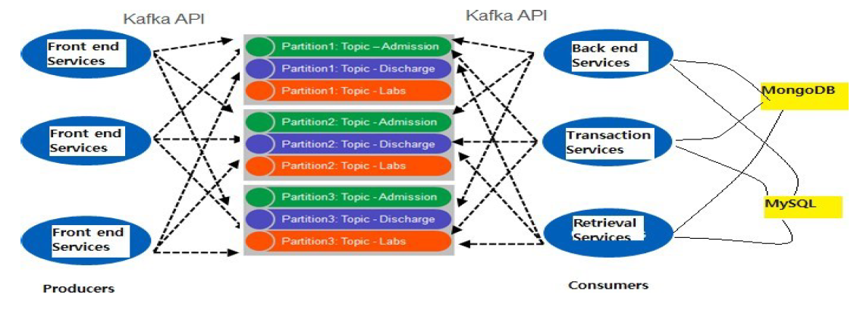

The application is basically split into three parts: frontend, backend, kafka-backend. The frontend consists of user UI elements made of HTML5, CSS, JS, ReactJS. The backend is split into node and kafka. Node gets data from user and sends it to kafka. Kafka being a distributed messaging system, gets data at Producers which places them to on queues in the kafka cluster. Consumer gets the data, makes appropriate database call and sends the result as response.

The above figure depicts the implementation of Kafka on backend server. This is used to achieve high throughput against many concurrent requests. It also facilitates fault tolerance because of replication. Zookeeper is used to manage the kafka cluster. Because of the limitation of the users, the replication factor and partitions are set to be one.

The database used to store data is a non-relational database – MongoDB. MongoDB implicitly provides connection pooling. It supports storing unstructured data and hence faster retrieval.

**Technologies**

Software: HTML5, CSS, Node.js, Express, ReactJS-Redux, MongoDB, Kafka, Bootstrap, Font Awesome, Material UI.

Hardware: Any computer with Google Chrome version 72 or later, or other compatible versions or browsers.

**Deployment**

Deployed on AWS using EC2 instance, putty and WinSCP.

**Database**

**User schema**

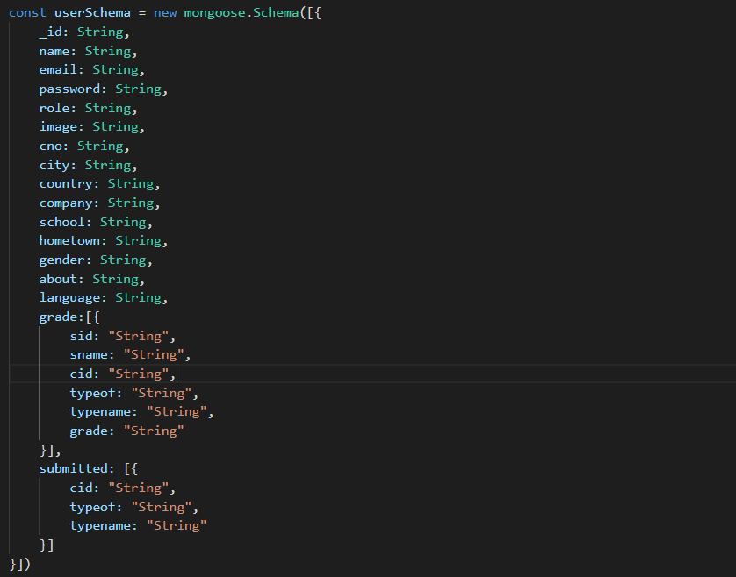

**Message Schema**

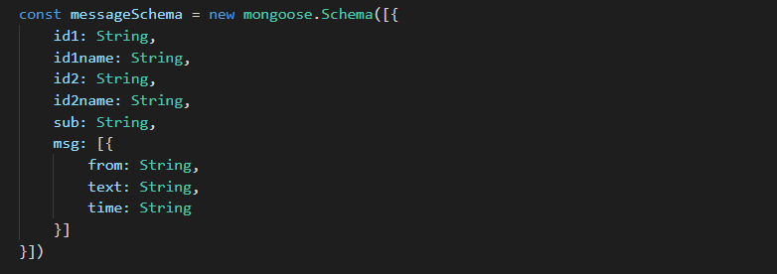

**Course Schema**

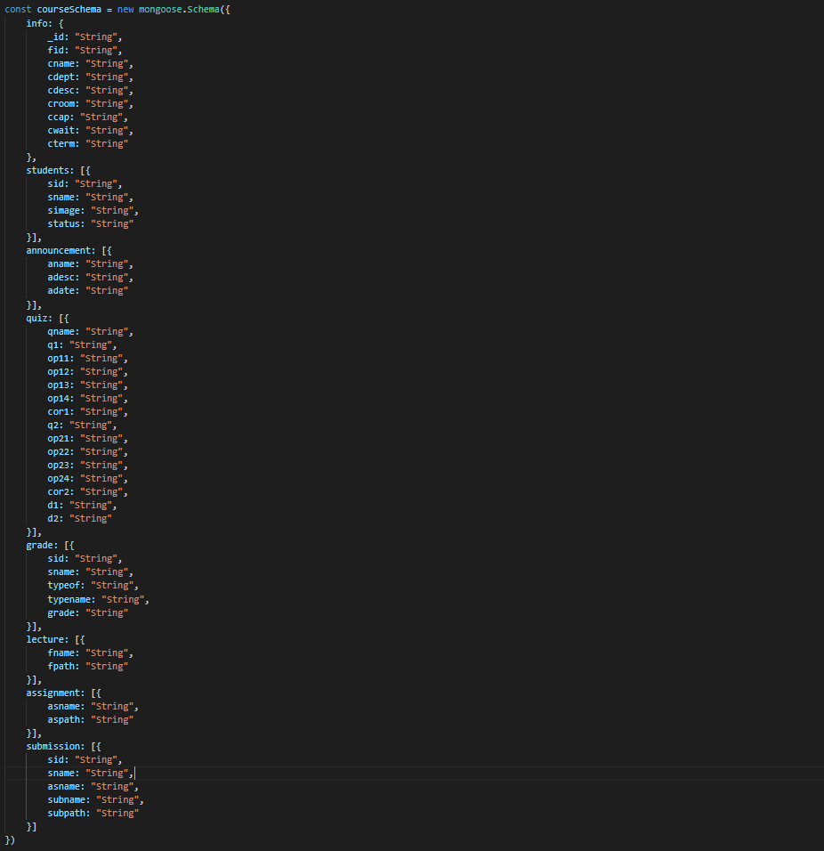

**Results**

The result of each request/response is shown as UI, backend response, kafka-backend response.

EC2 instance DNS : ec2-18-191-66-39.us-east-2.compute.amazonaws.com

Signup

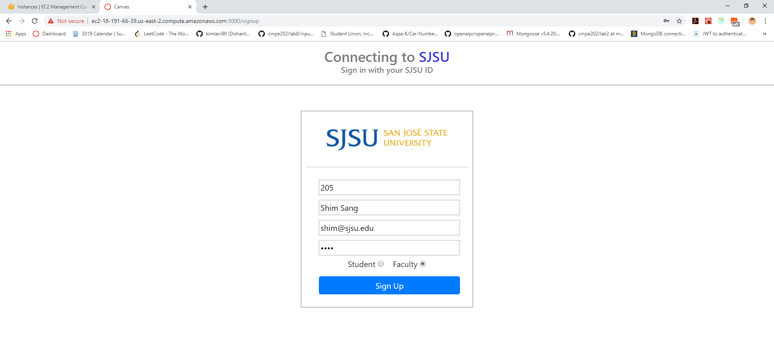





Login

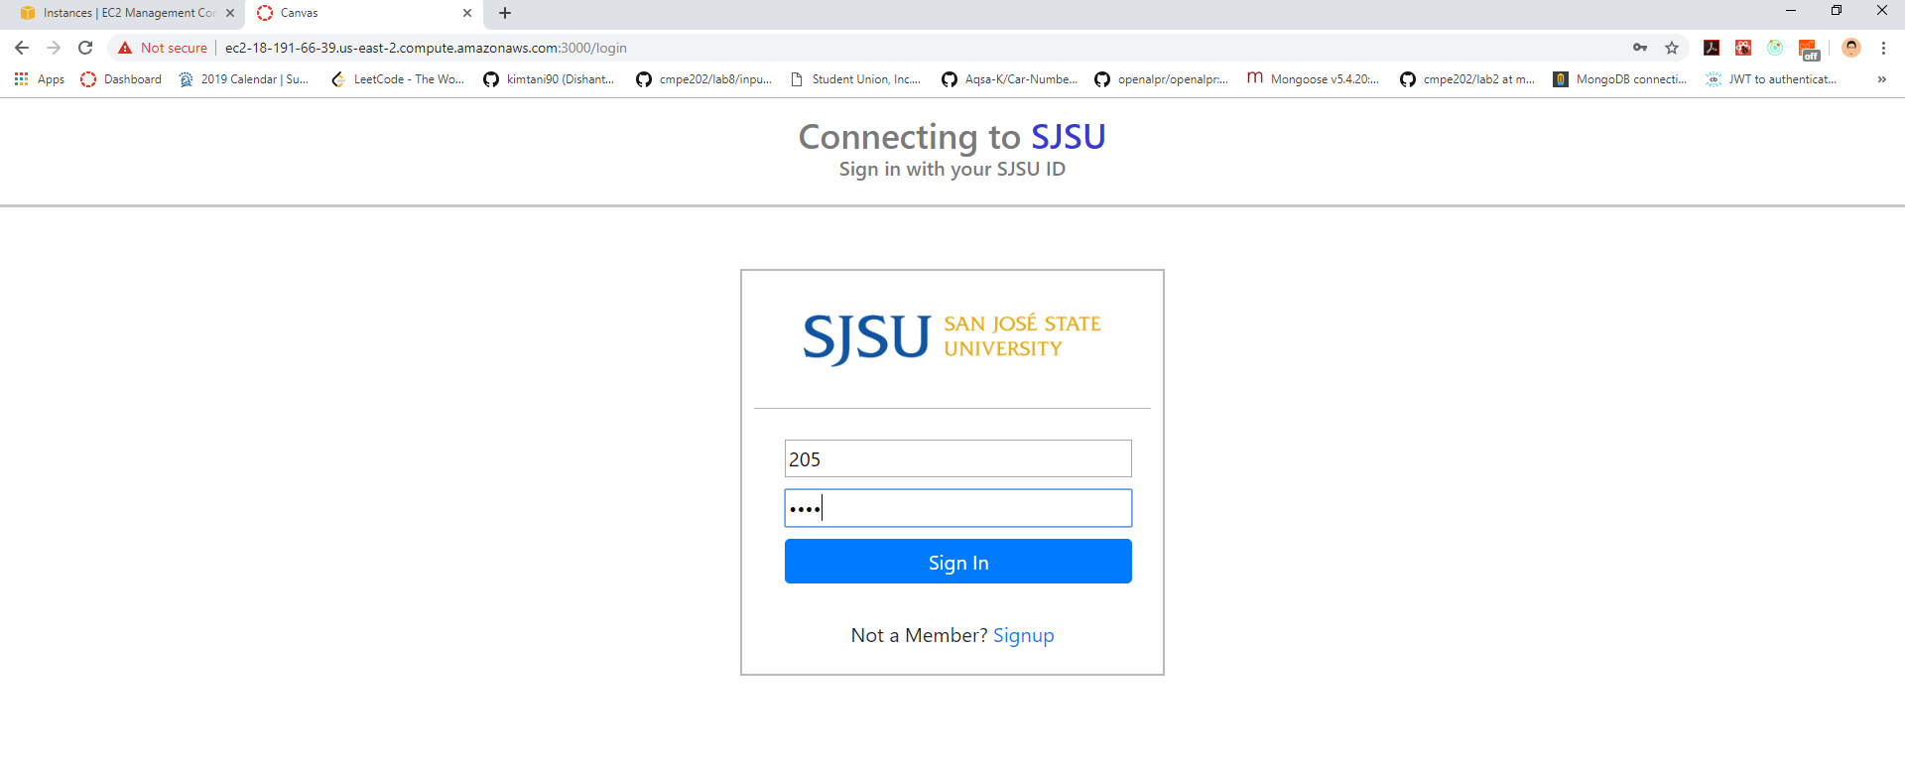



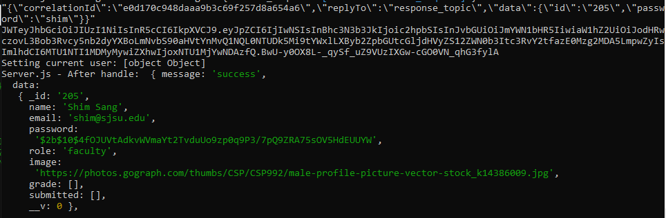

Dashboard view

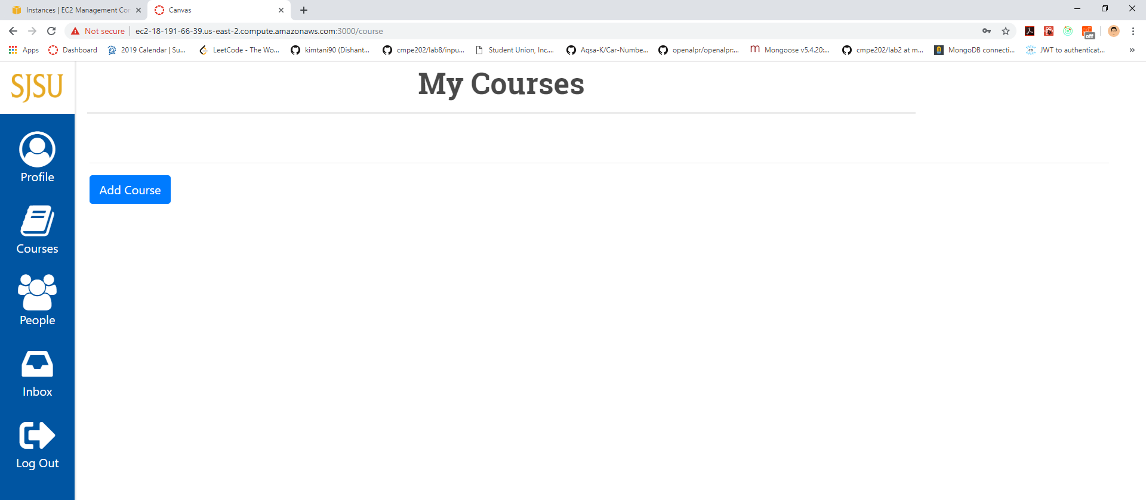

View with courses enrolled / created.

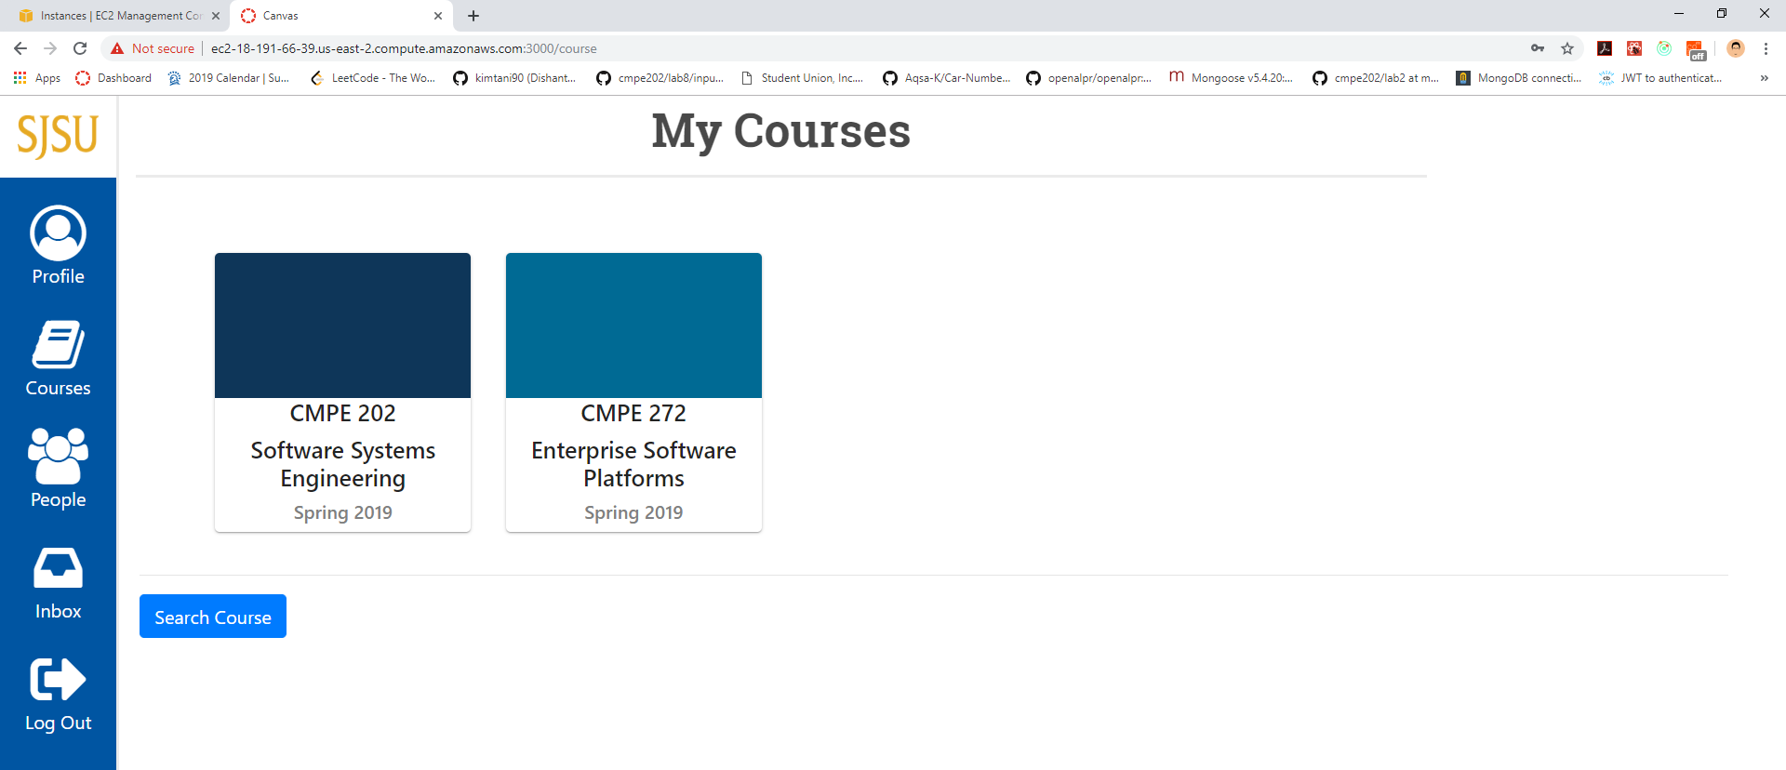

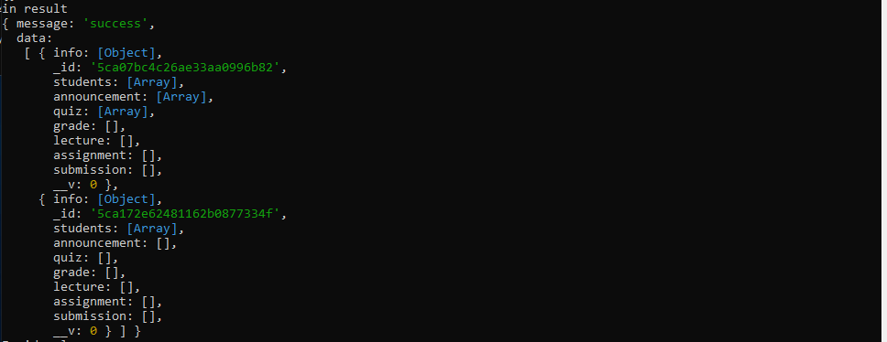

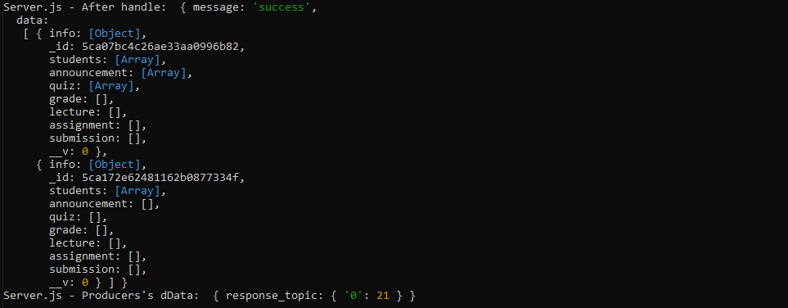

Organizing Dashboard with draggable courses

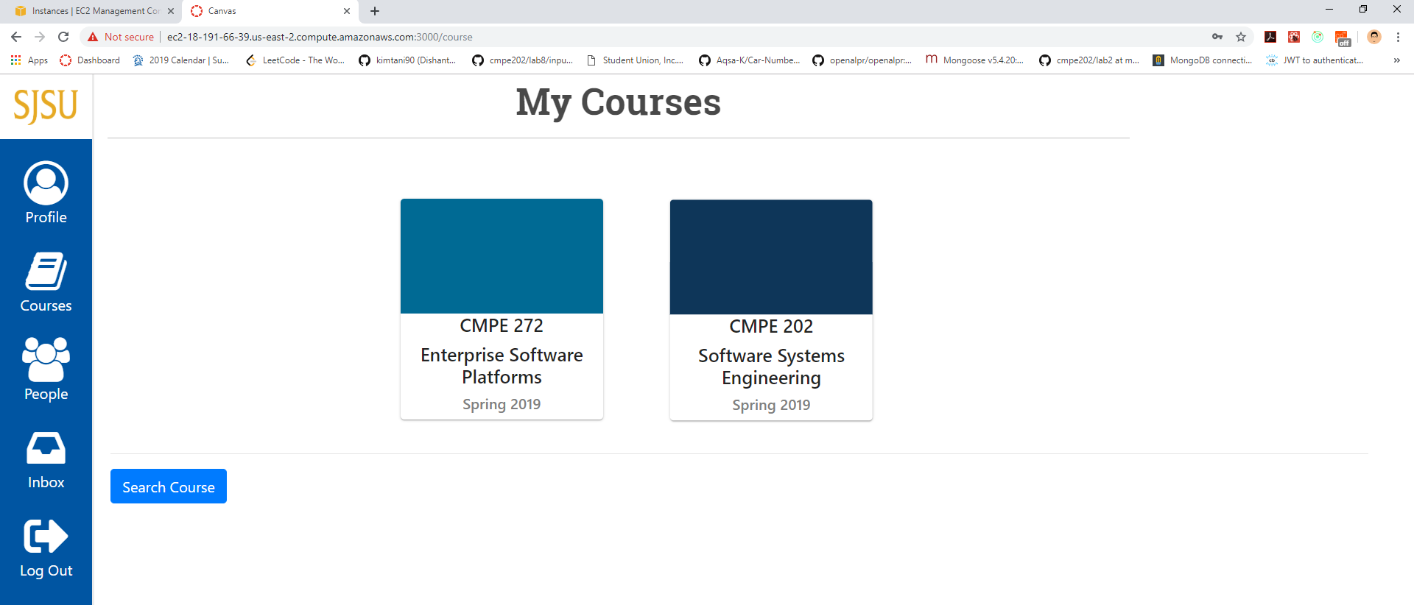

Profile view

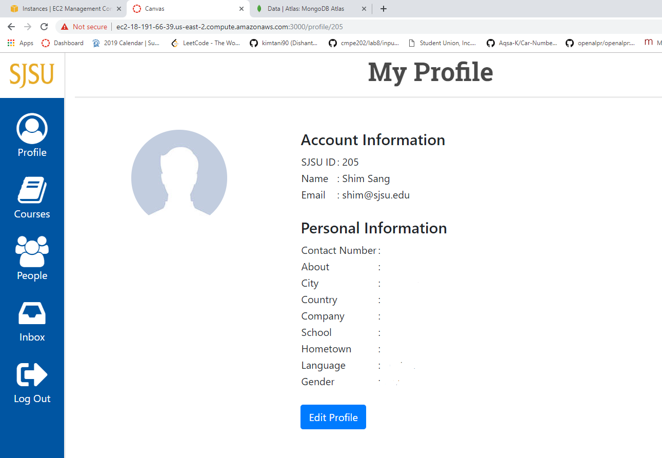

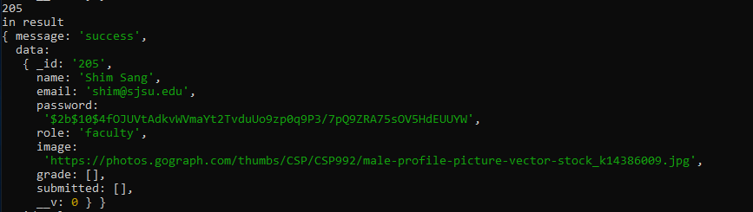

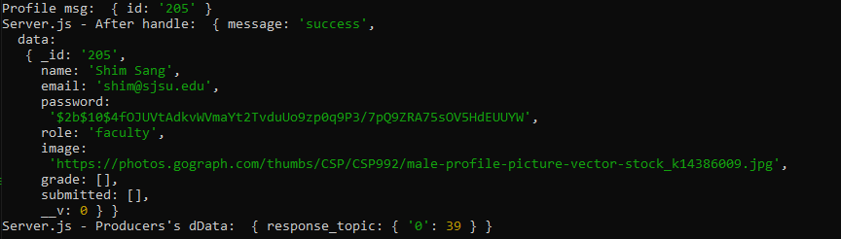

Edit Profile

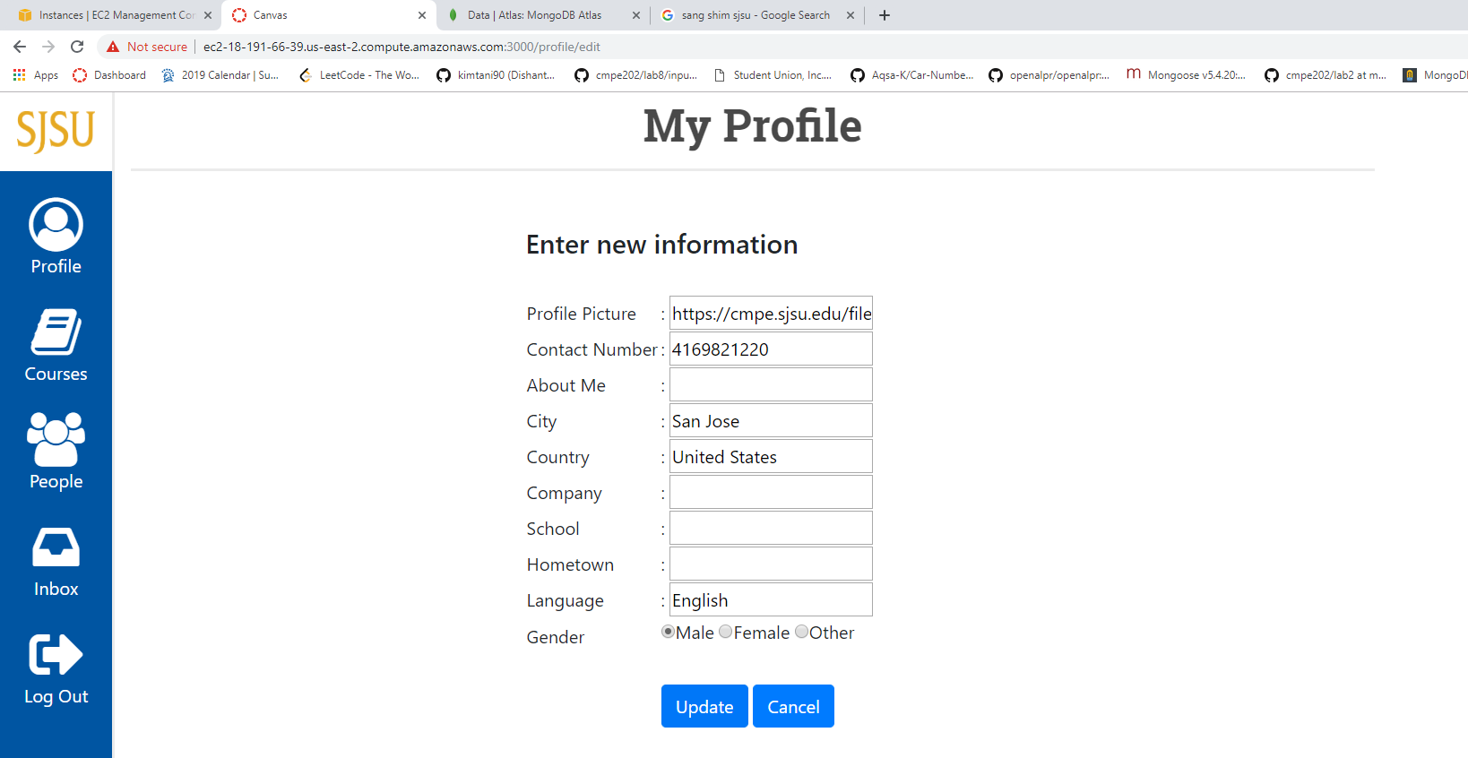

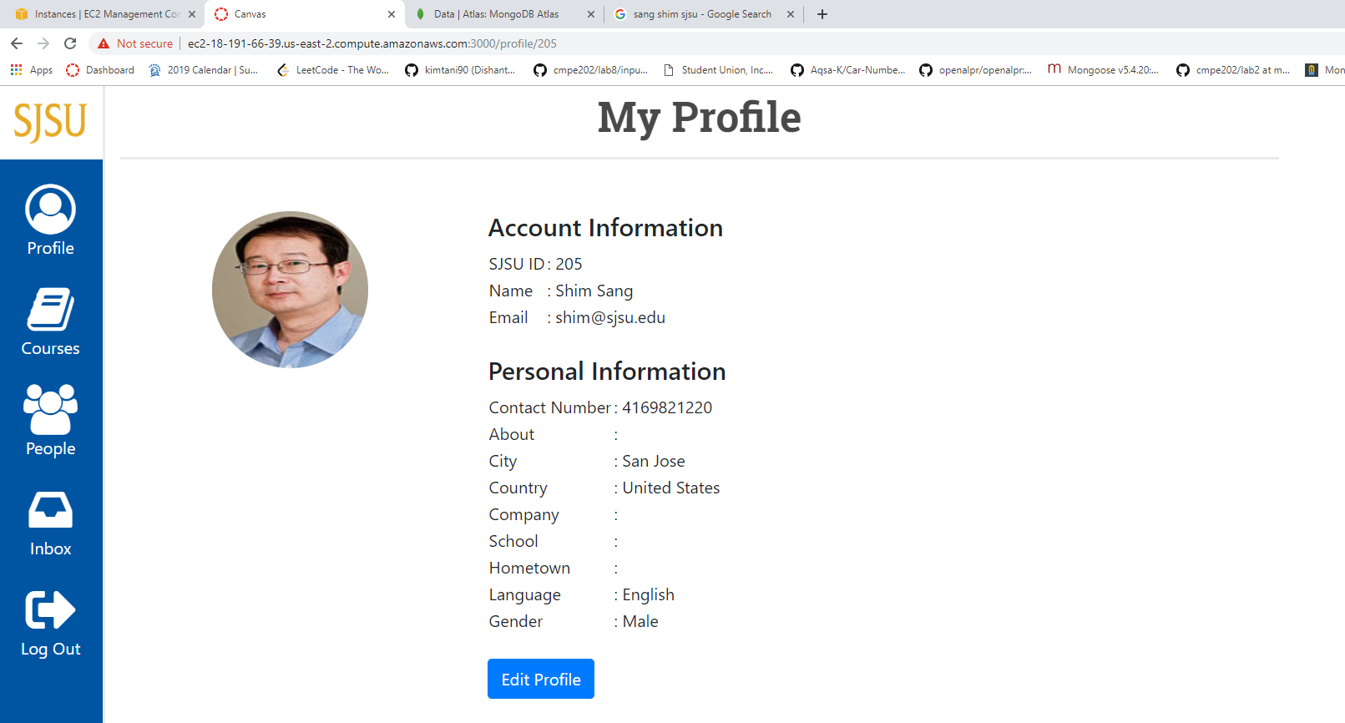

Profile is updated through redux store.

People view with pagination

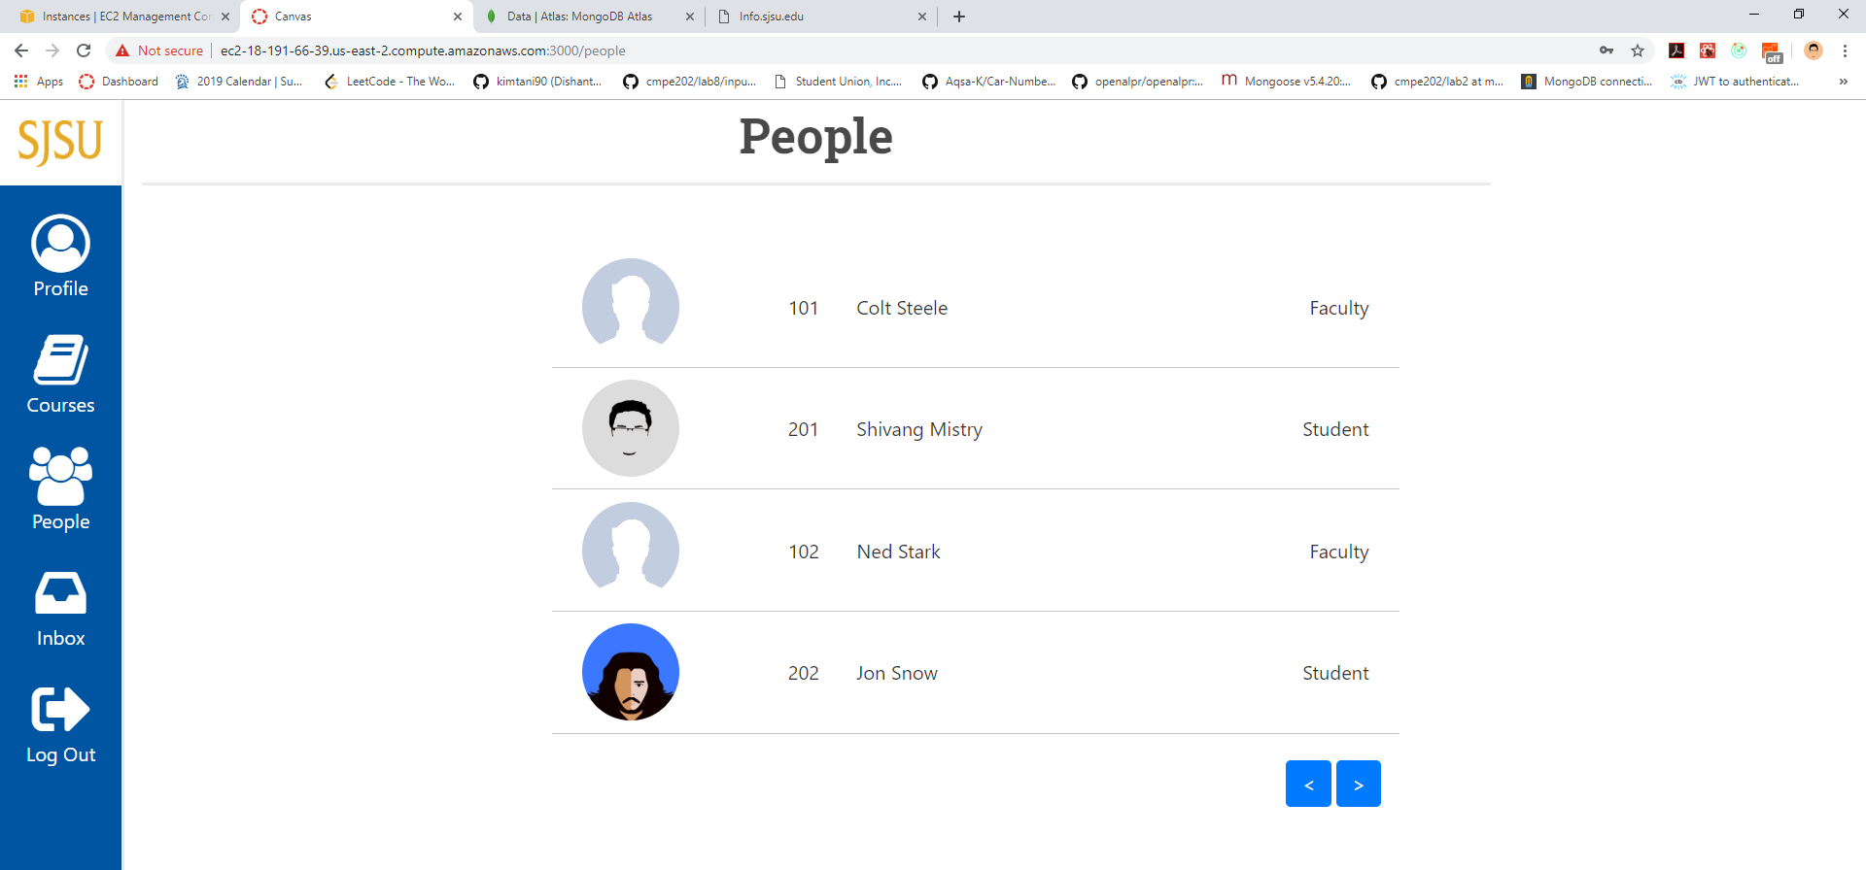

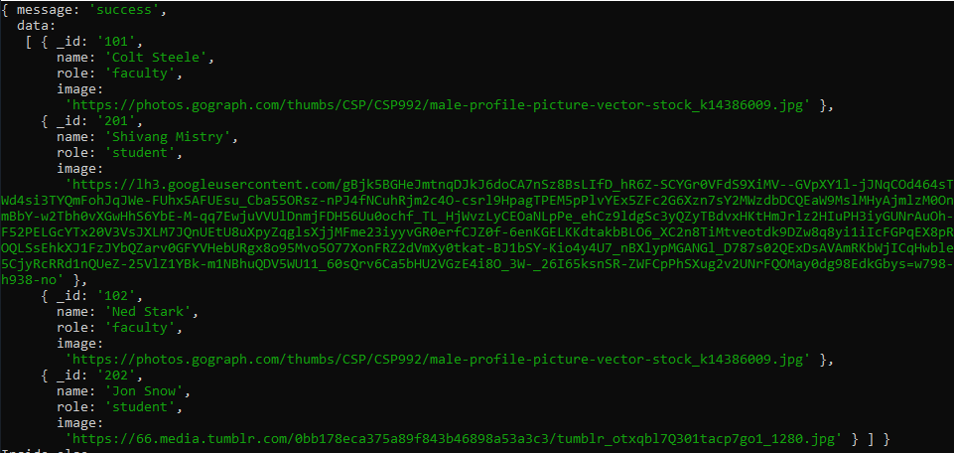

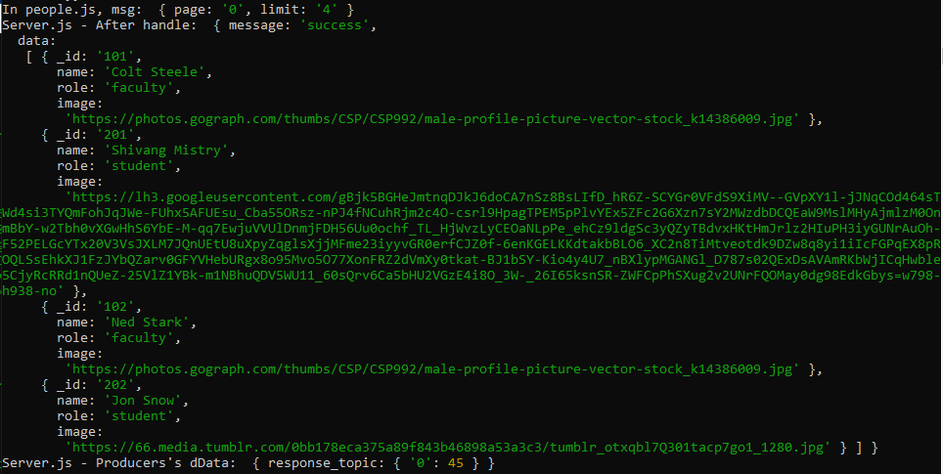

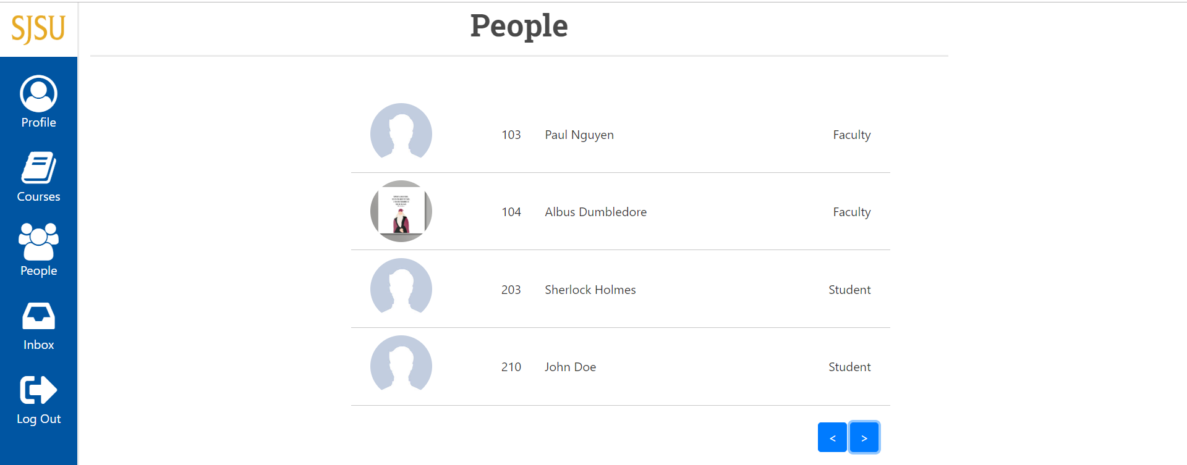

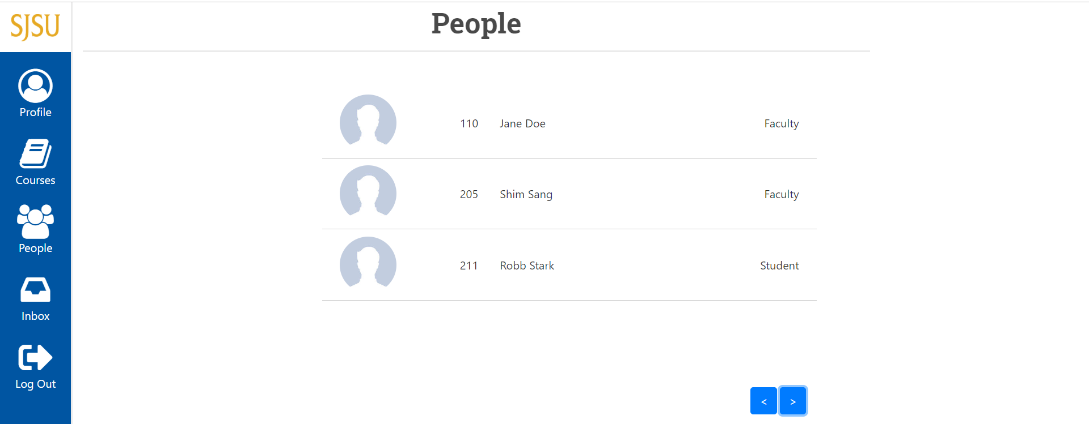

Inbox view

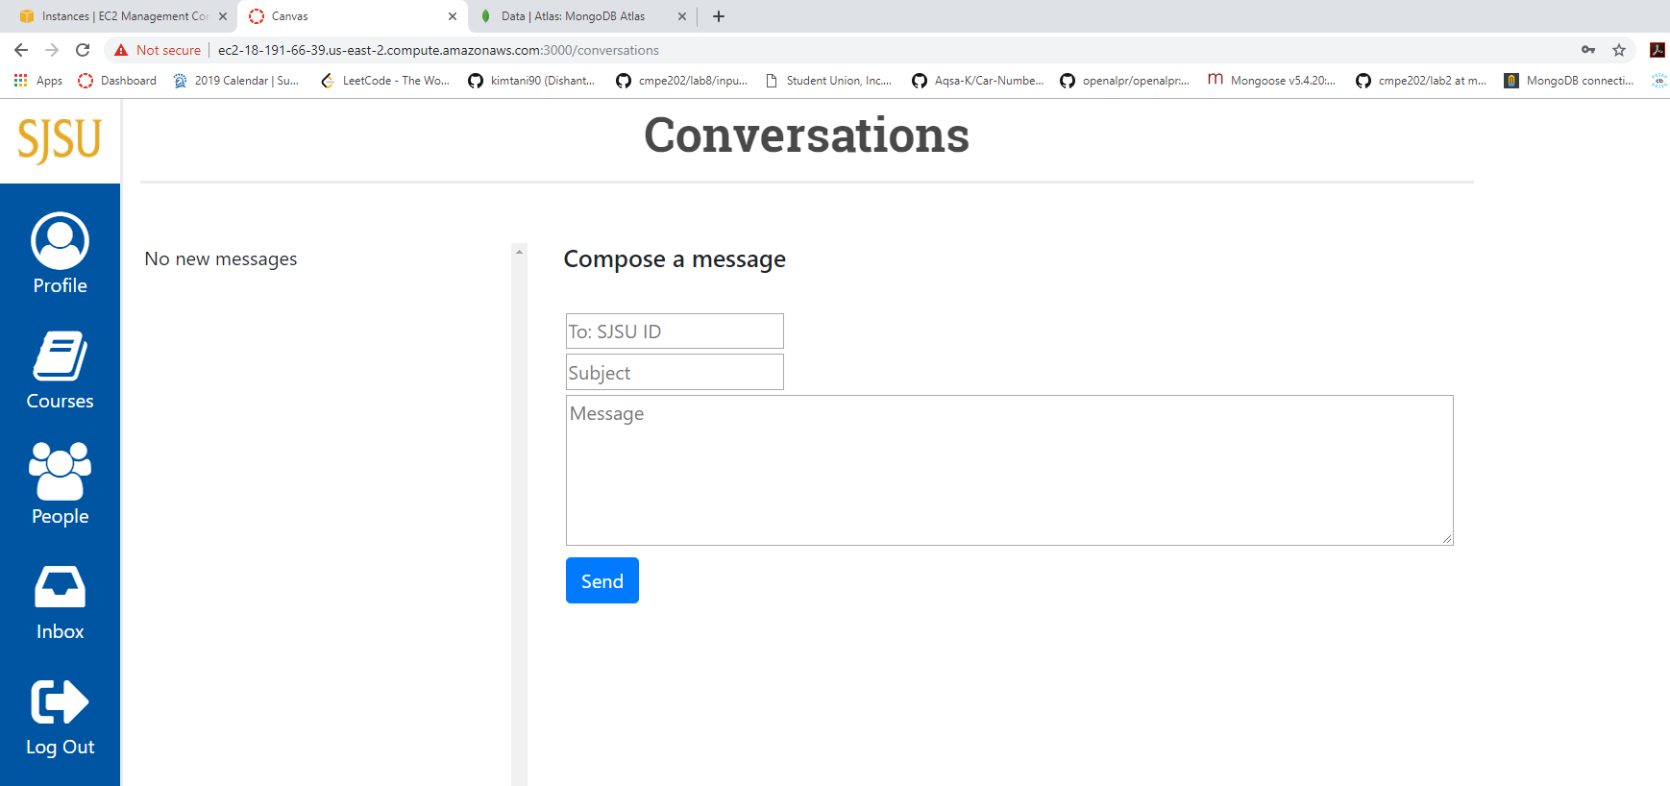





Composing new message

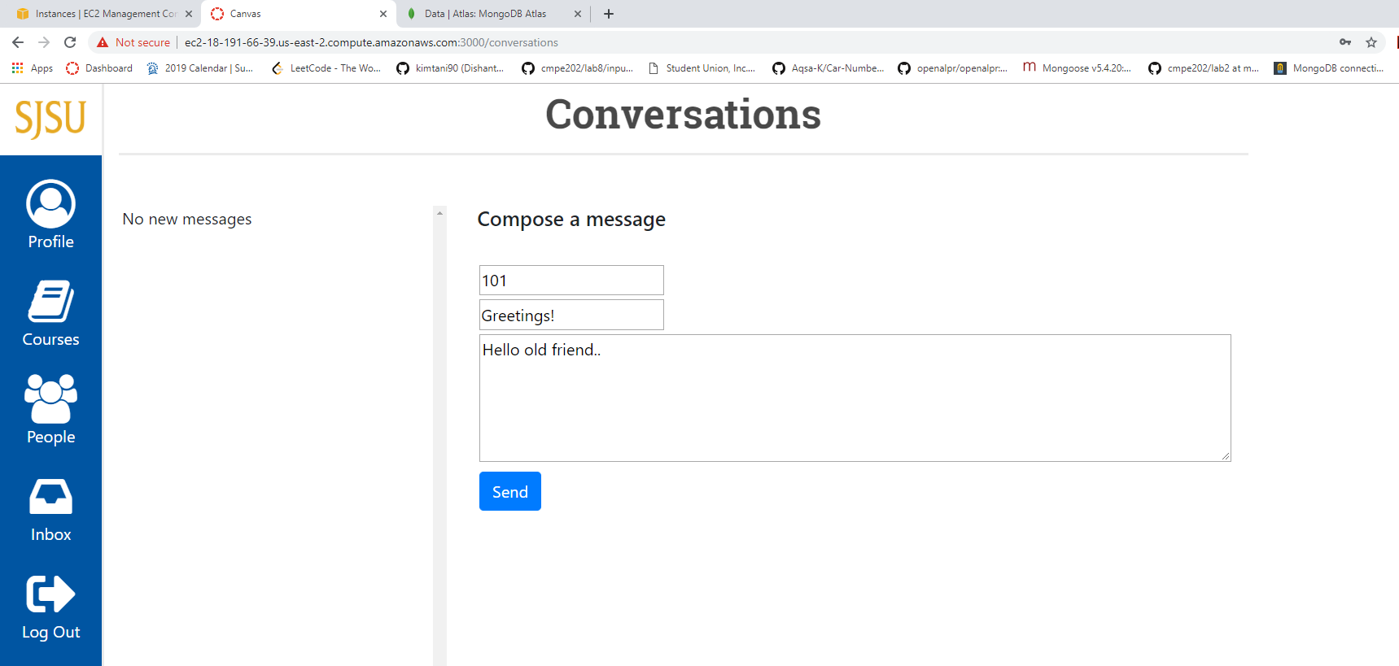

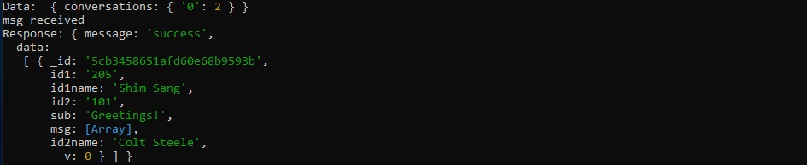



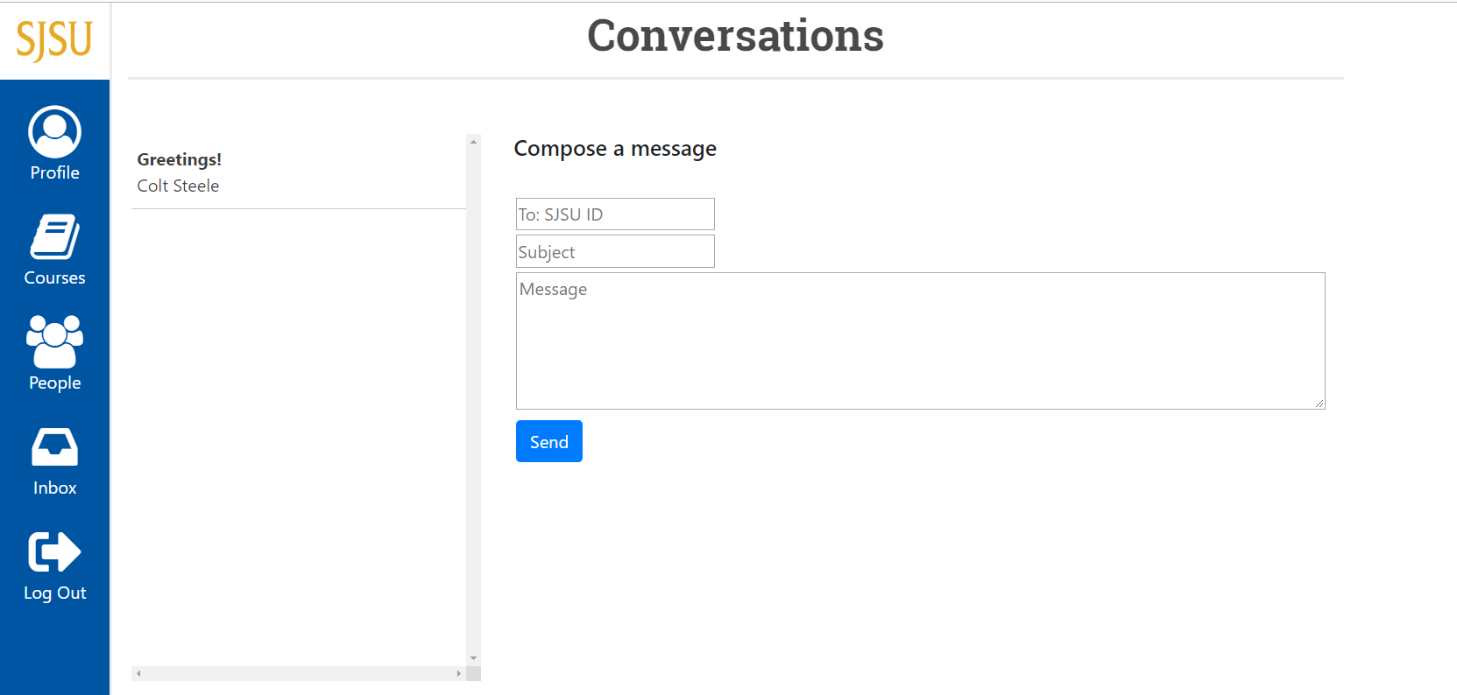

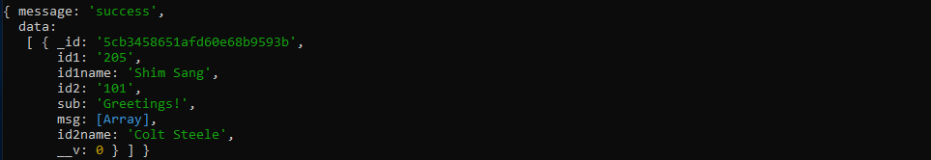

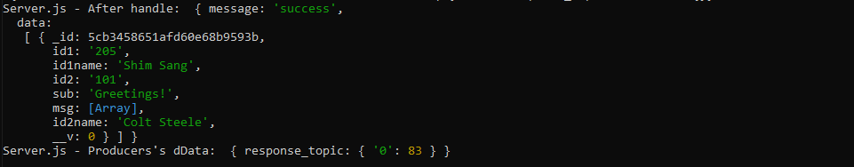

Message receiver

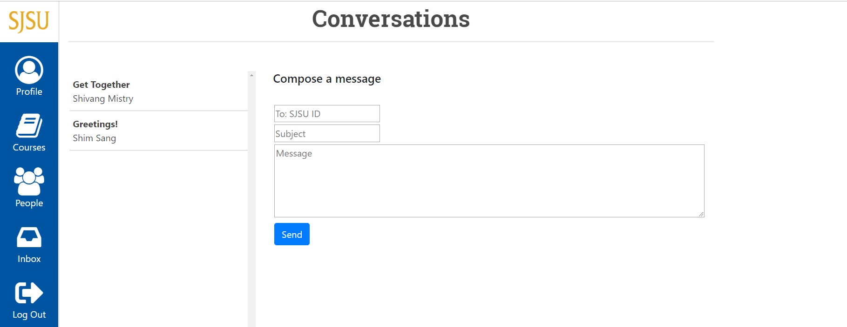

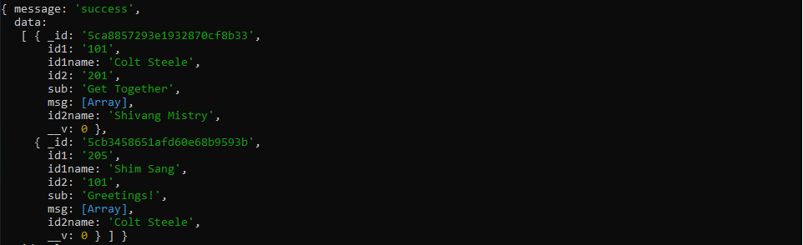

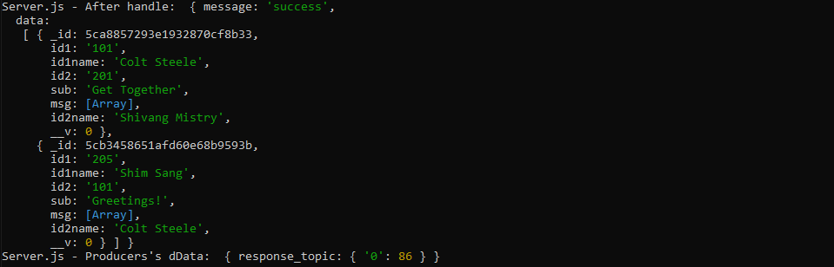

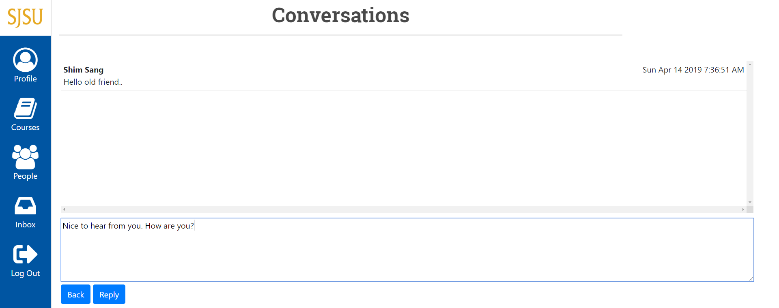

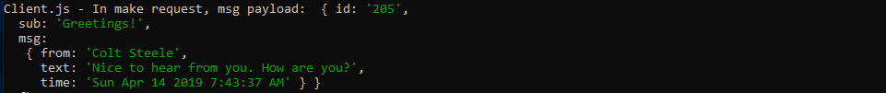

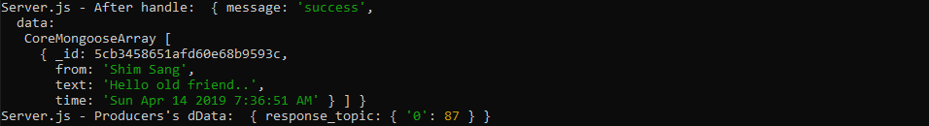

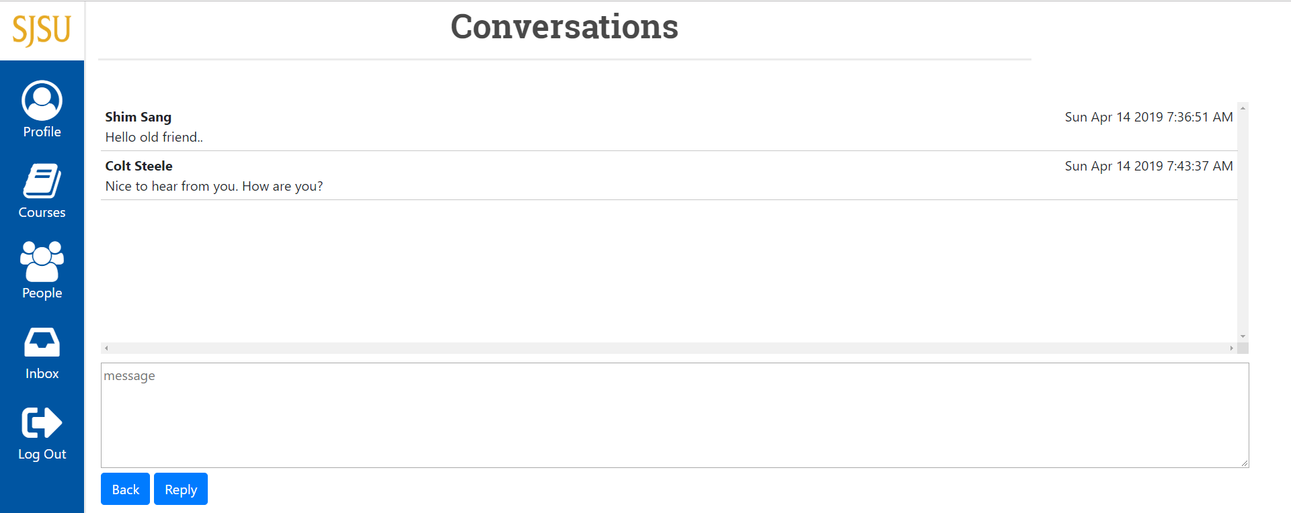

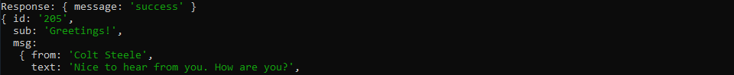



Course search by student with pagination

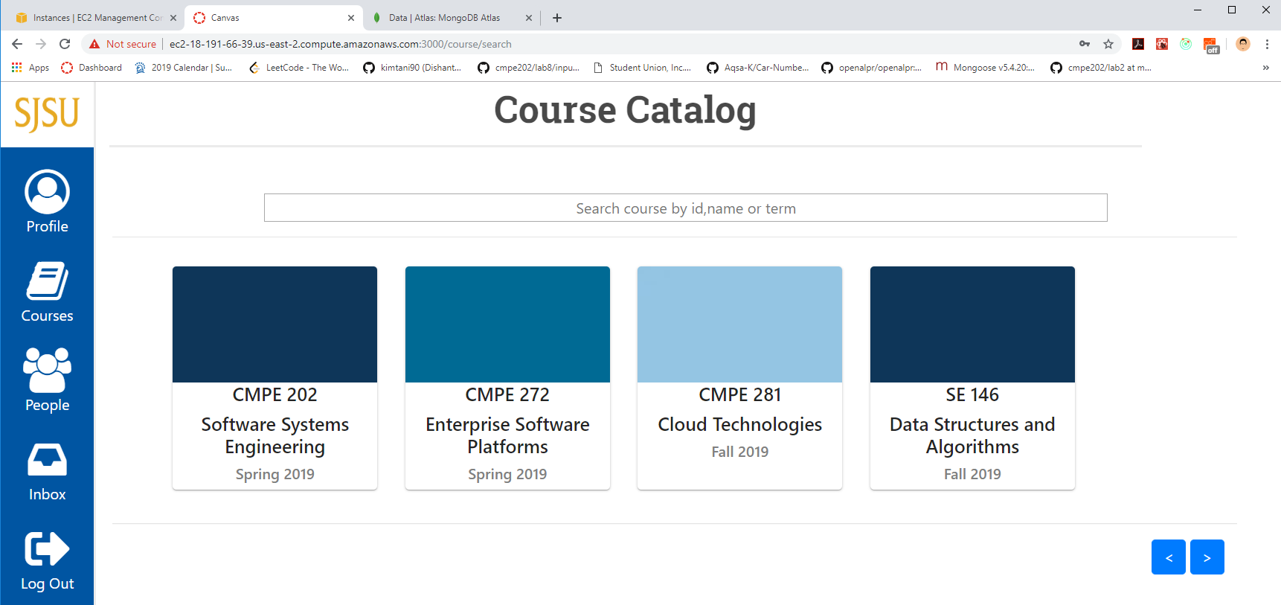

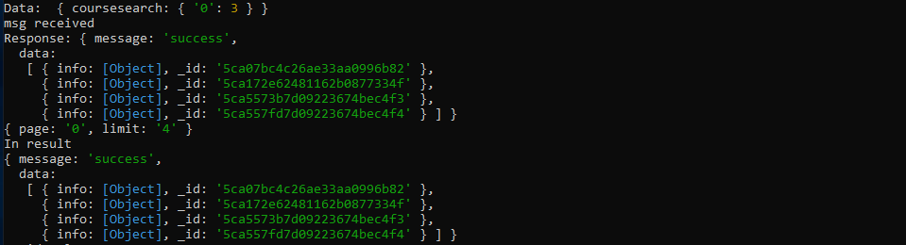

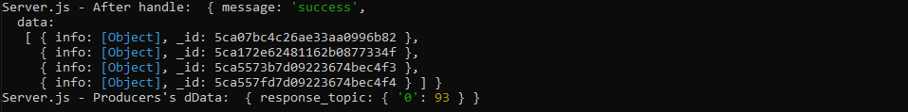

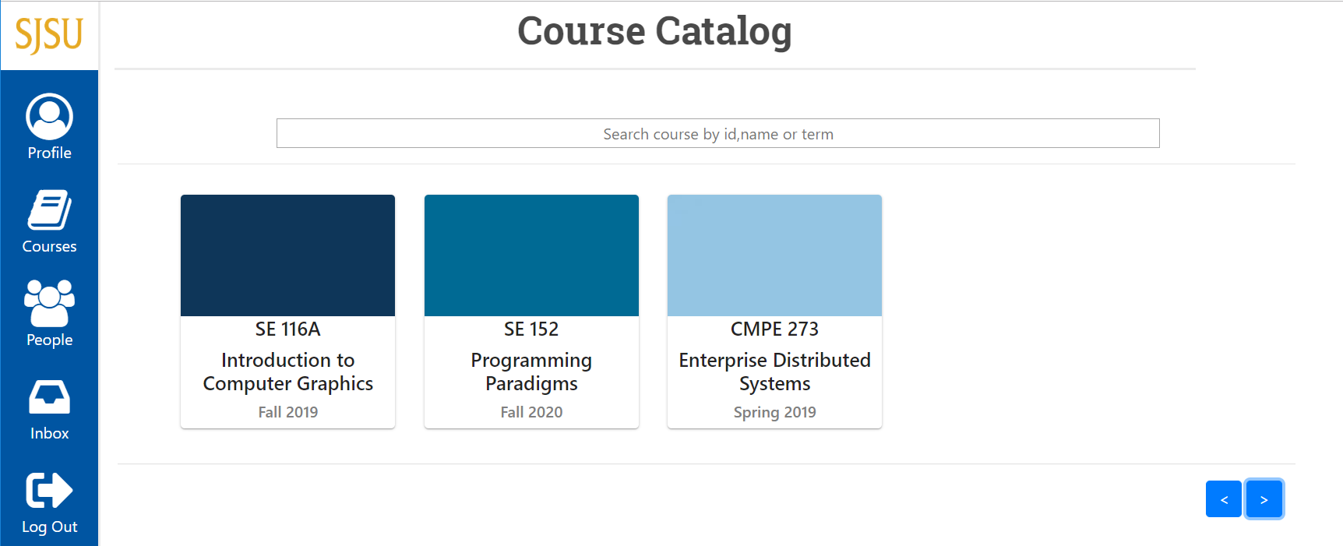

Course creation by faculty

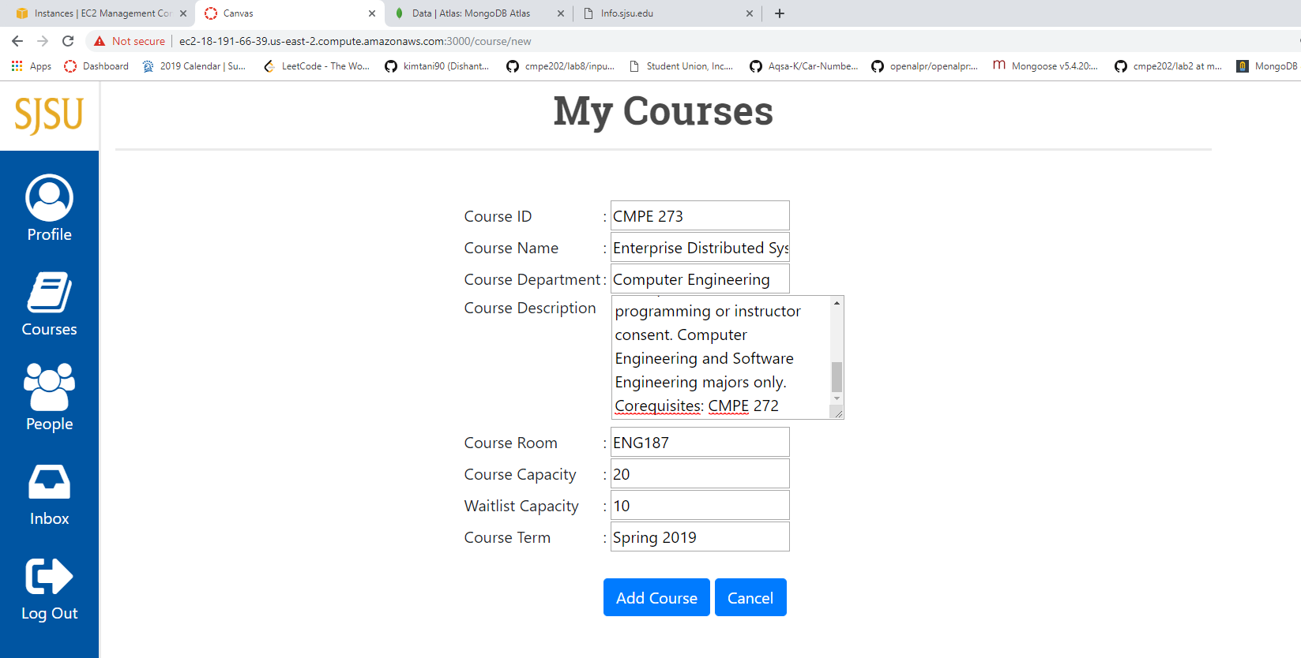

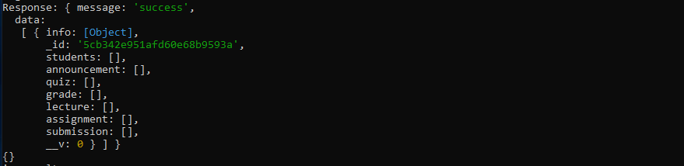

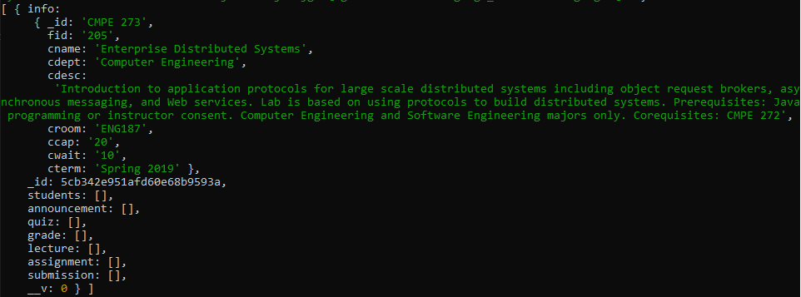

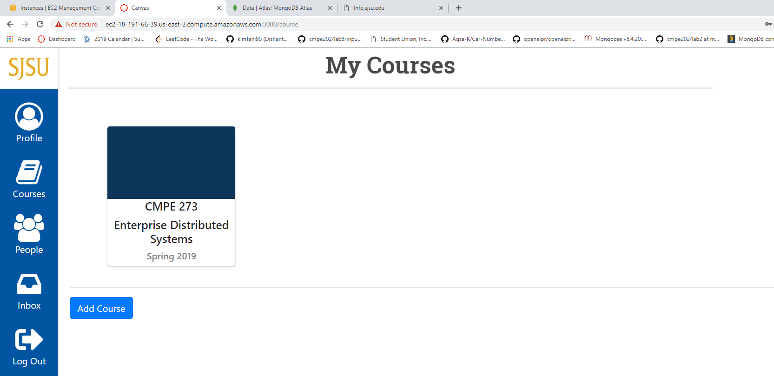

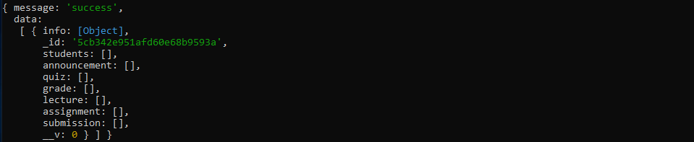

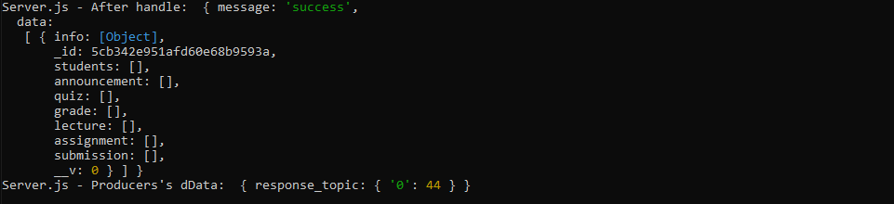

Course view for faculty

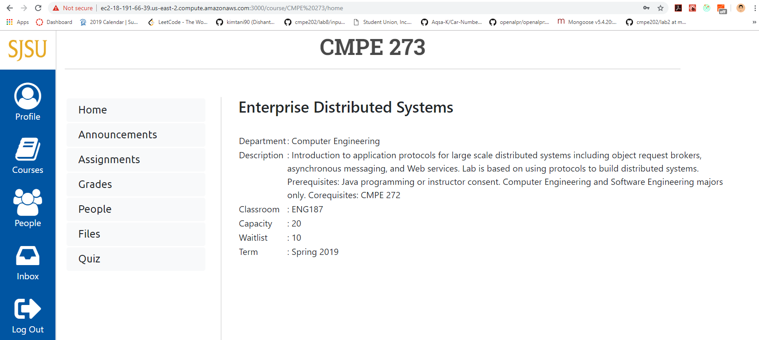

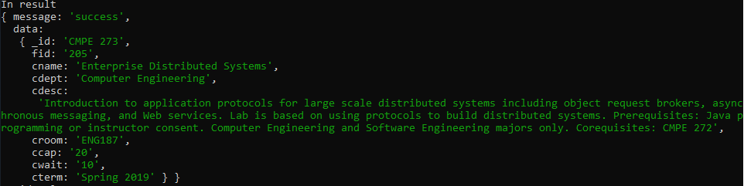

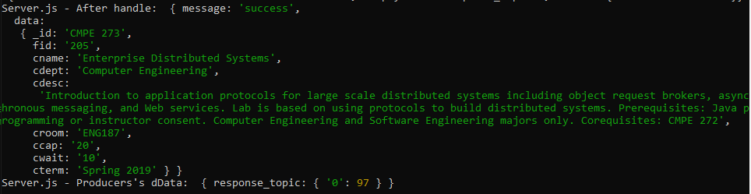

Course view for student not enrolled in that course

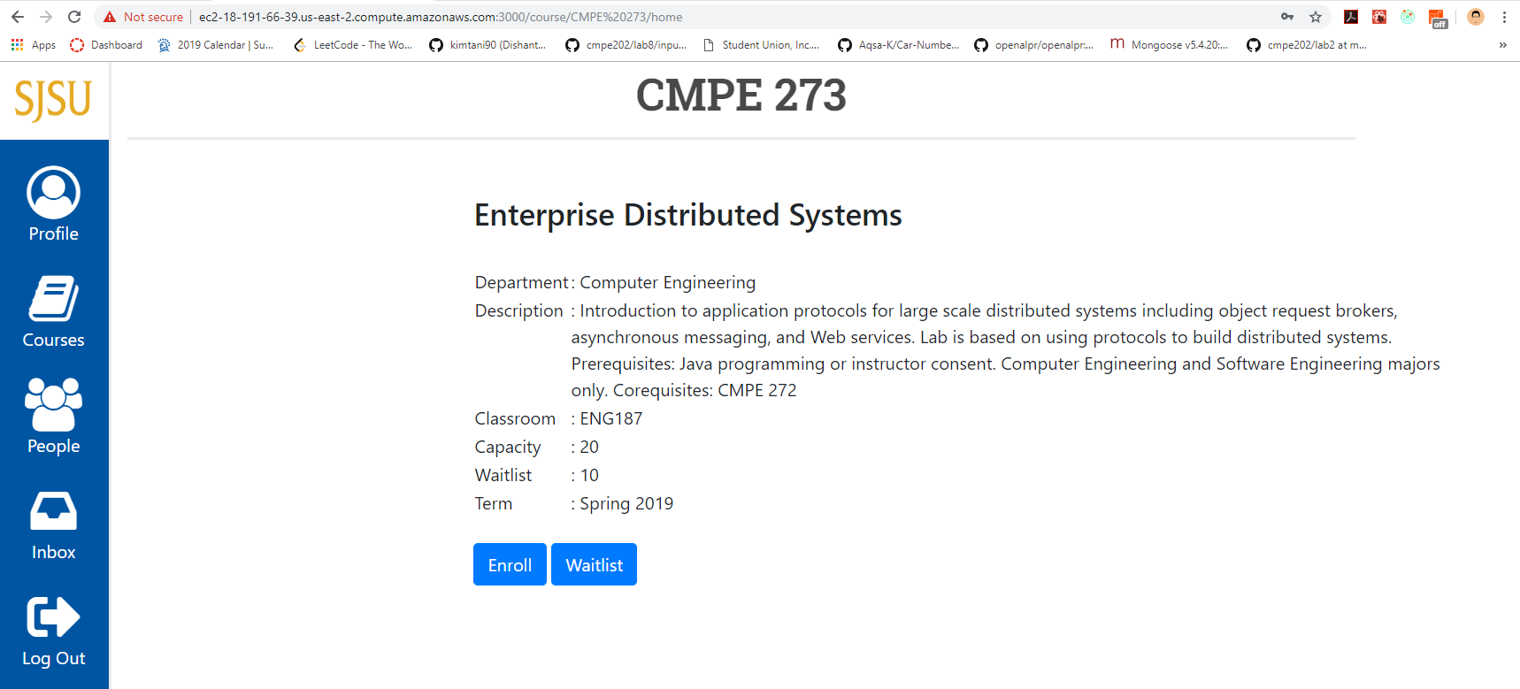

View for student enrolled / waitlisted

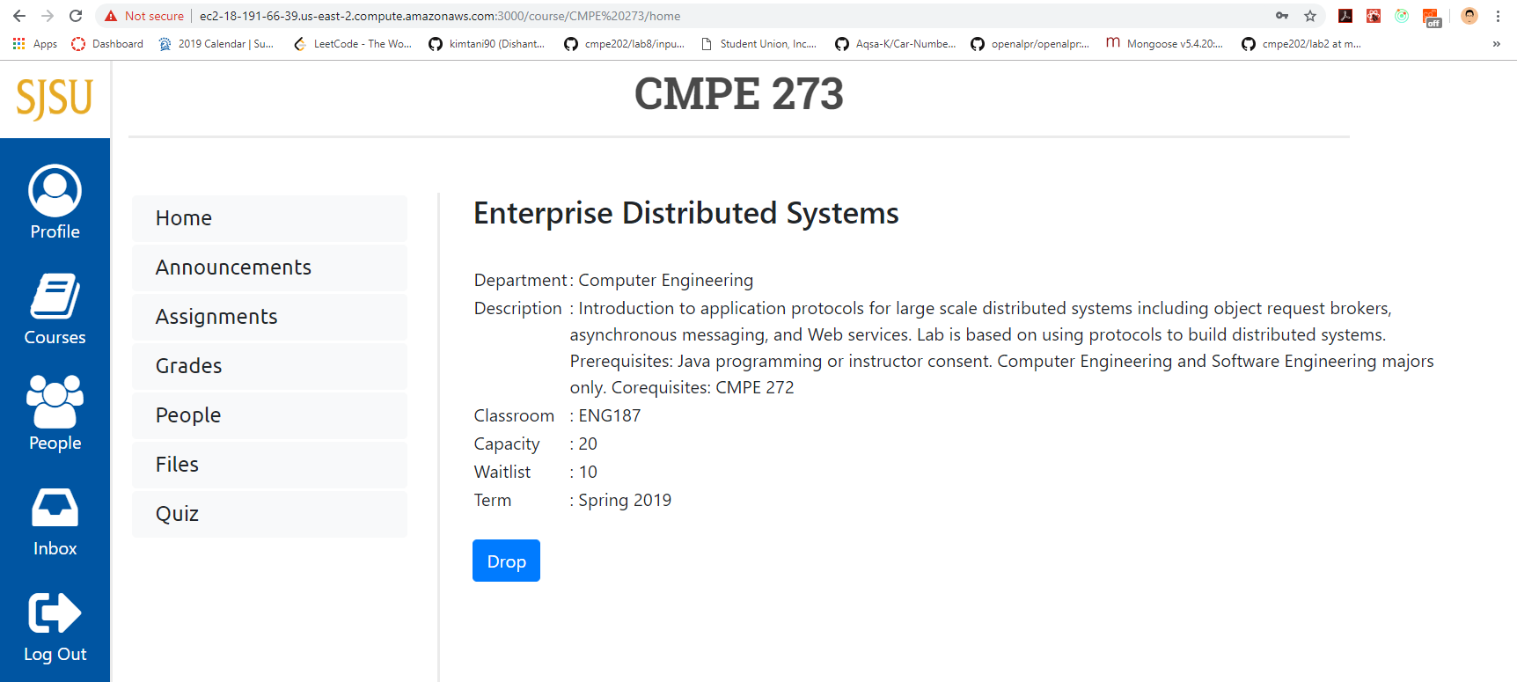



Course Announcements view for Faculty

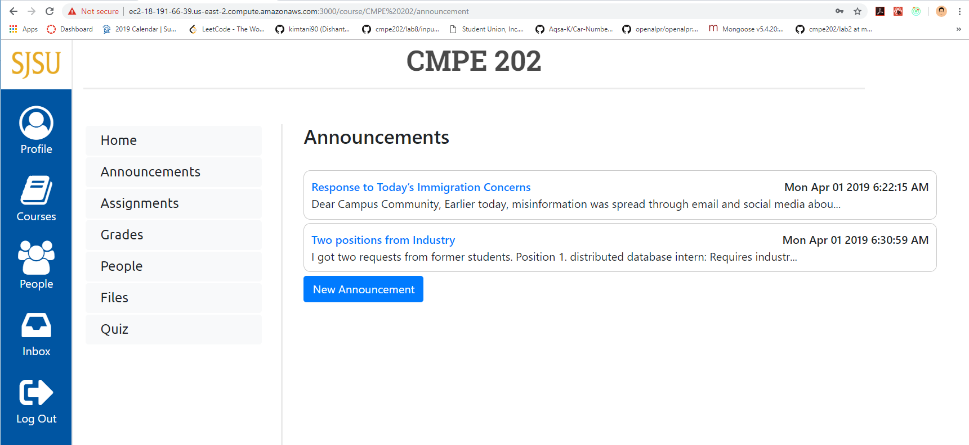

Course Announcements view for Student

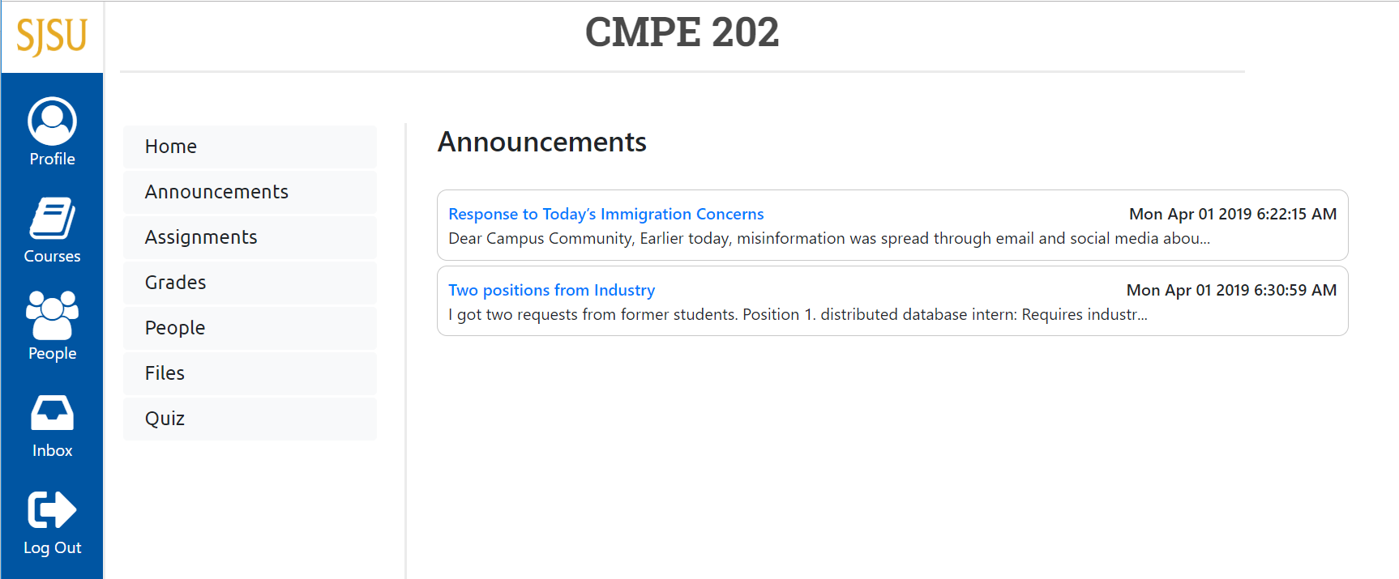

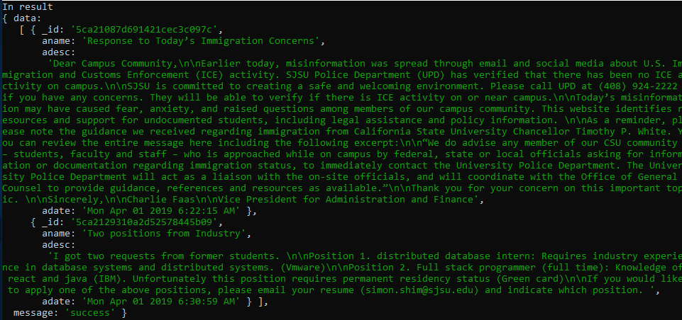

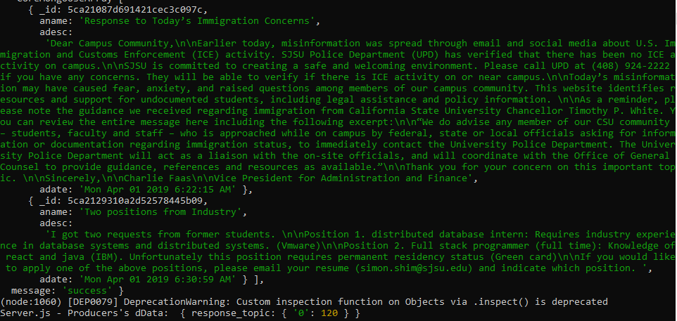

New Announcement

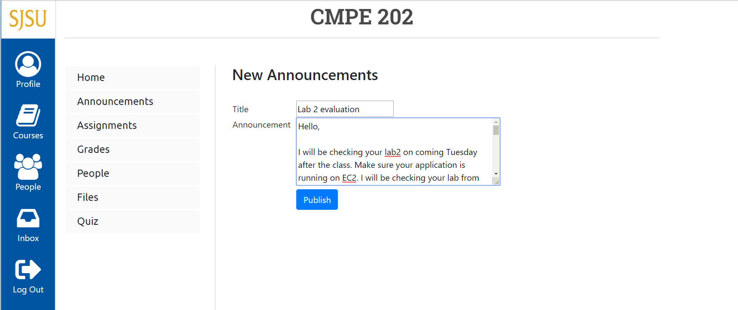

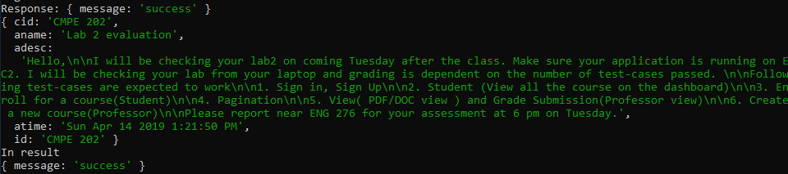

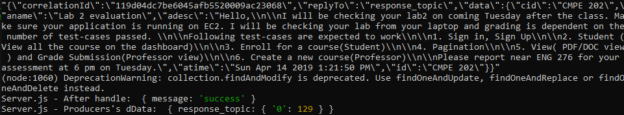

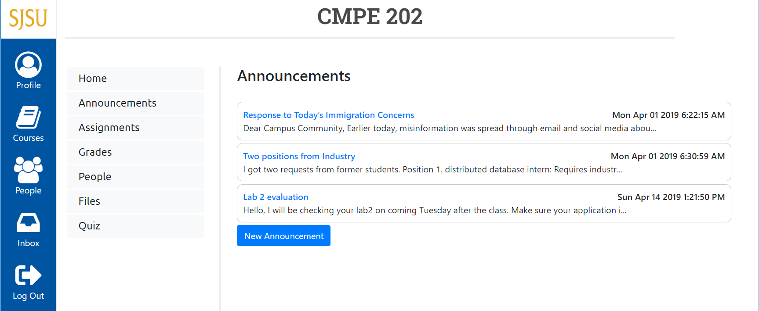



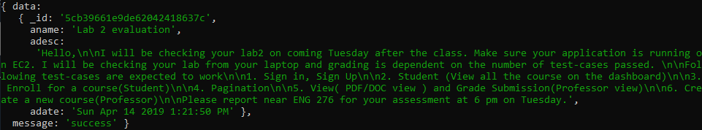

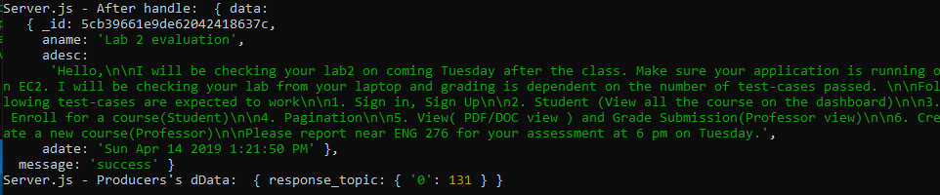

Course Assignments view for faculty



Course Assignments view for student







Faculty creating assignment



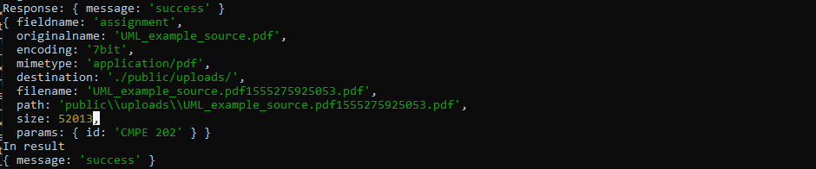

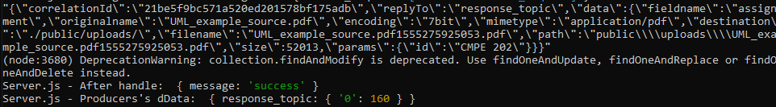



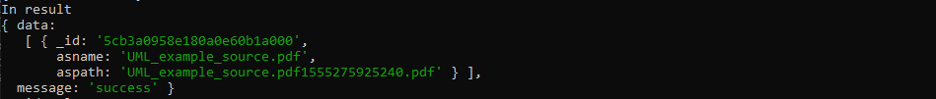

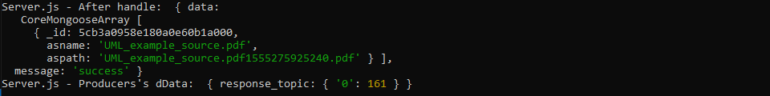

Student submitting assignment





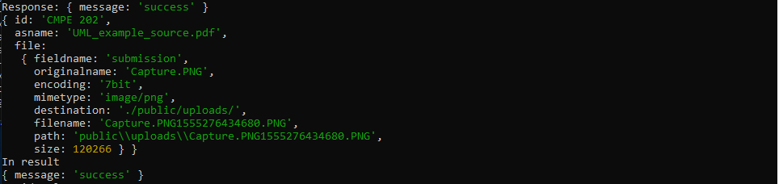

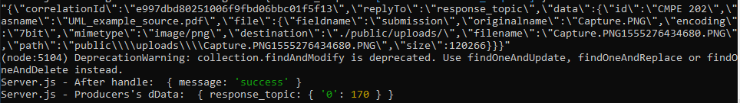

Faculty grading the assignment



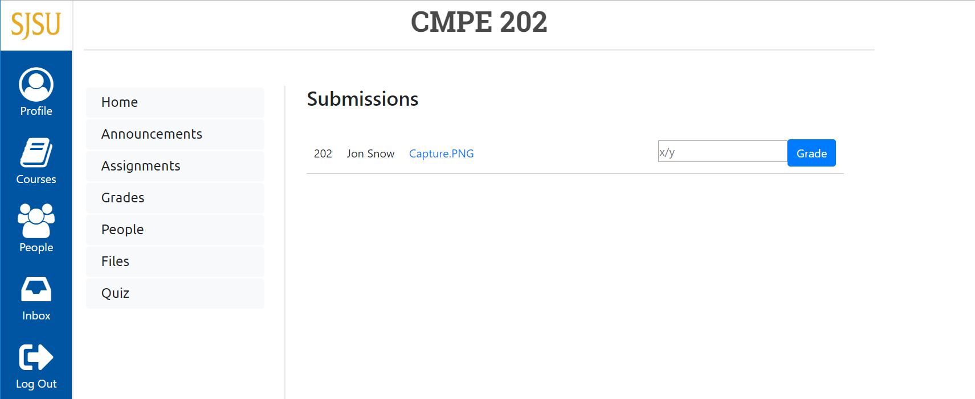

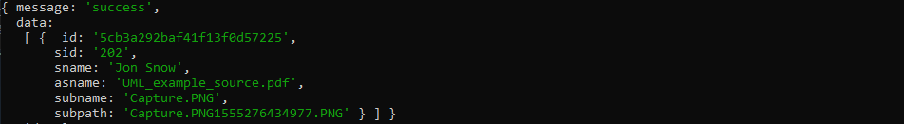

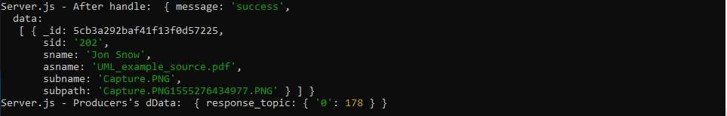

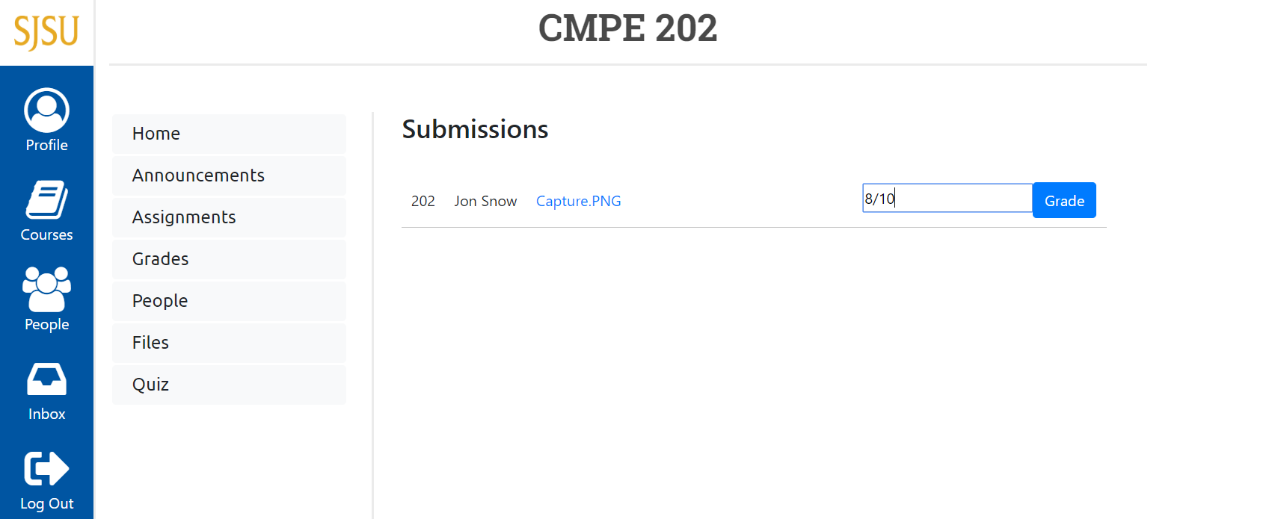

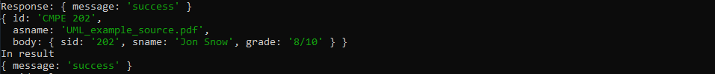



Grade view for faculty

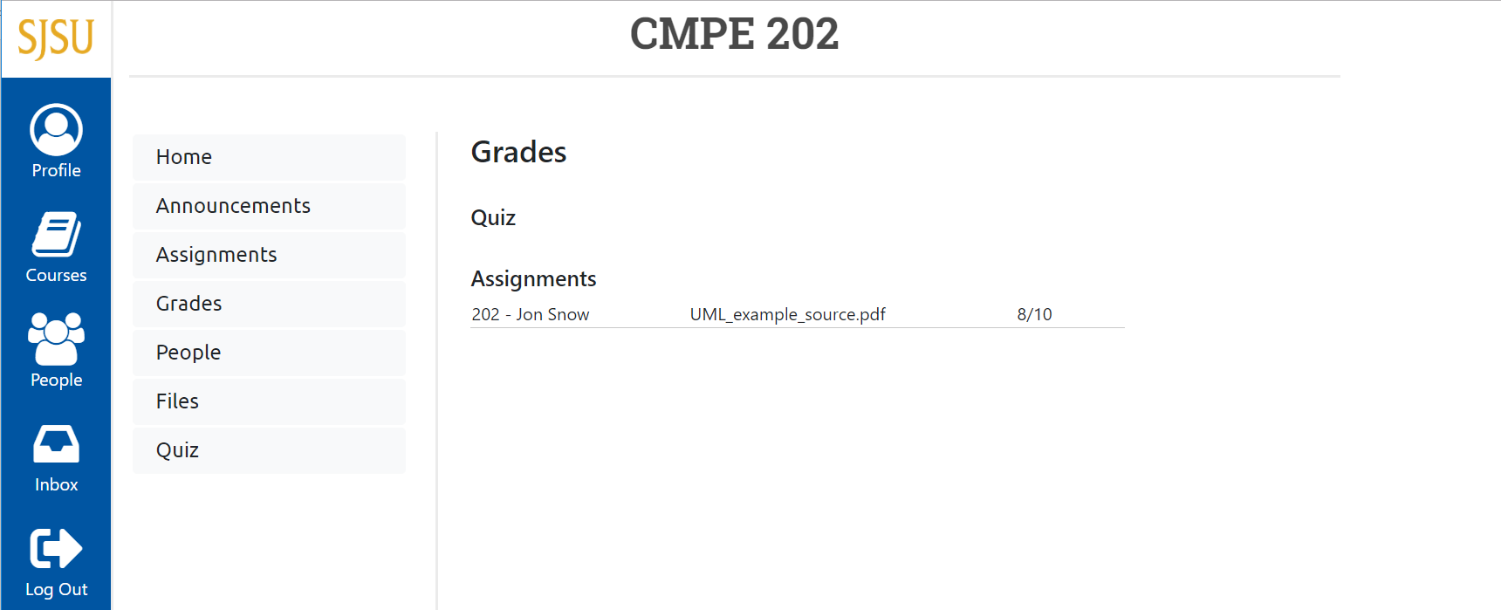

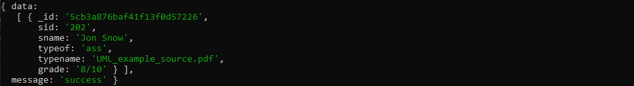

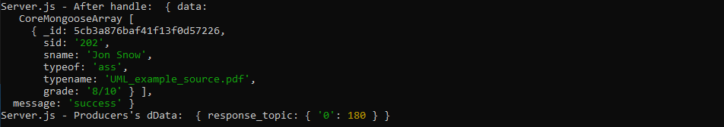

Grade view for student



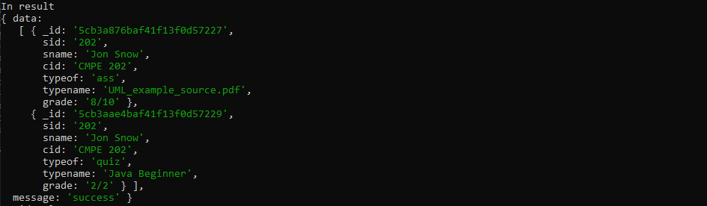

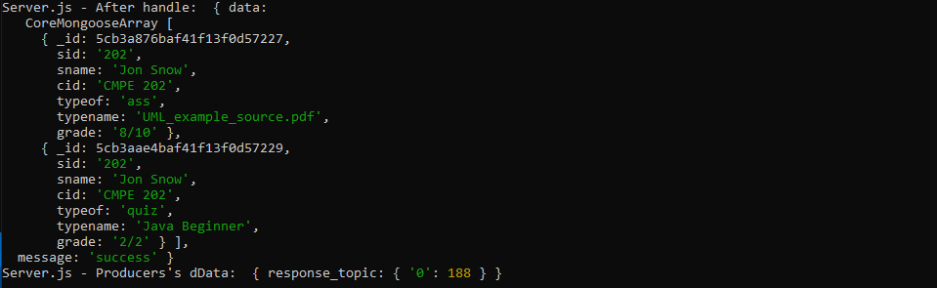

People view for Faculty

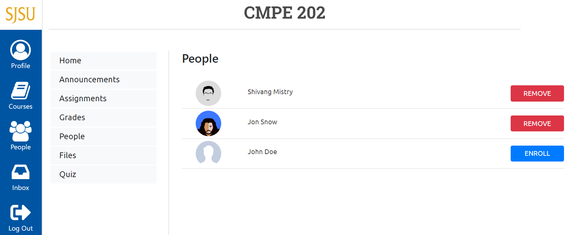

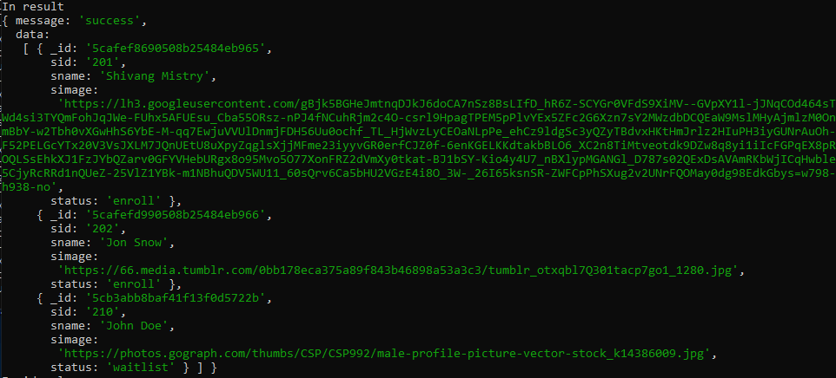

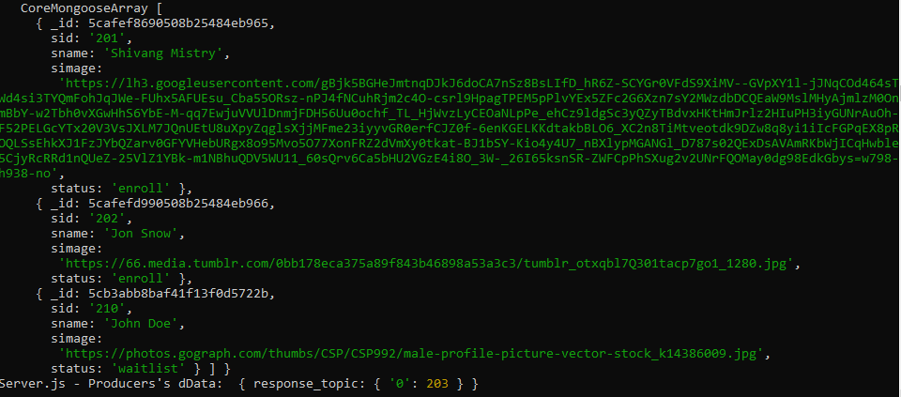

Faculty removing student

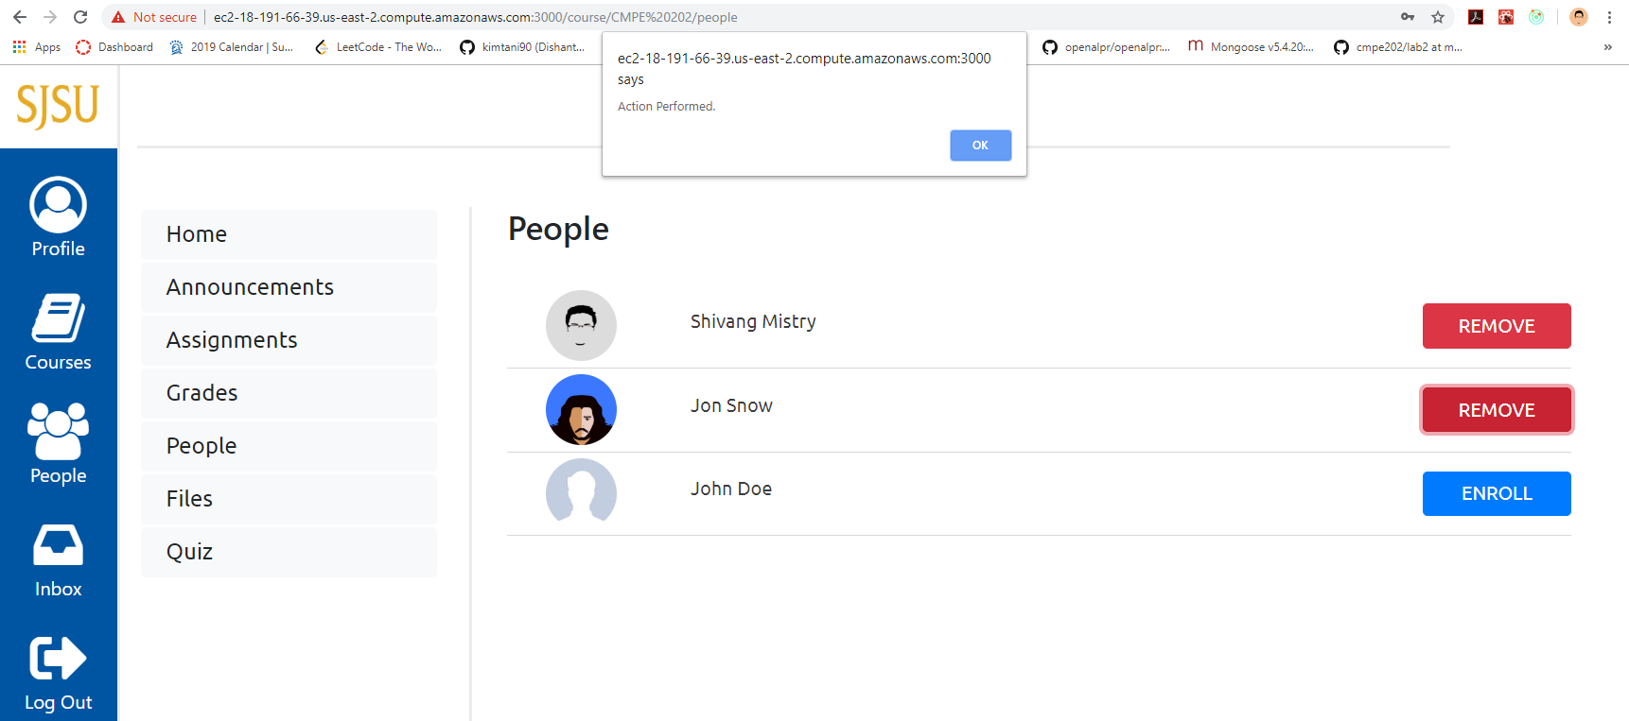



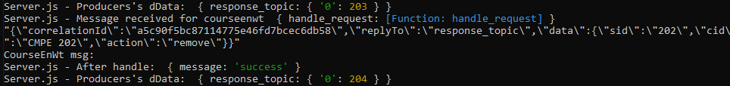

Faculty enrolling student by generating permission number

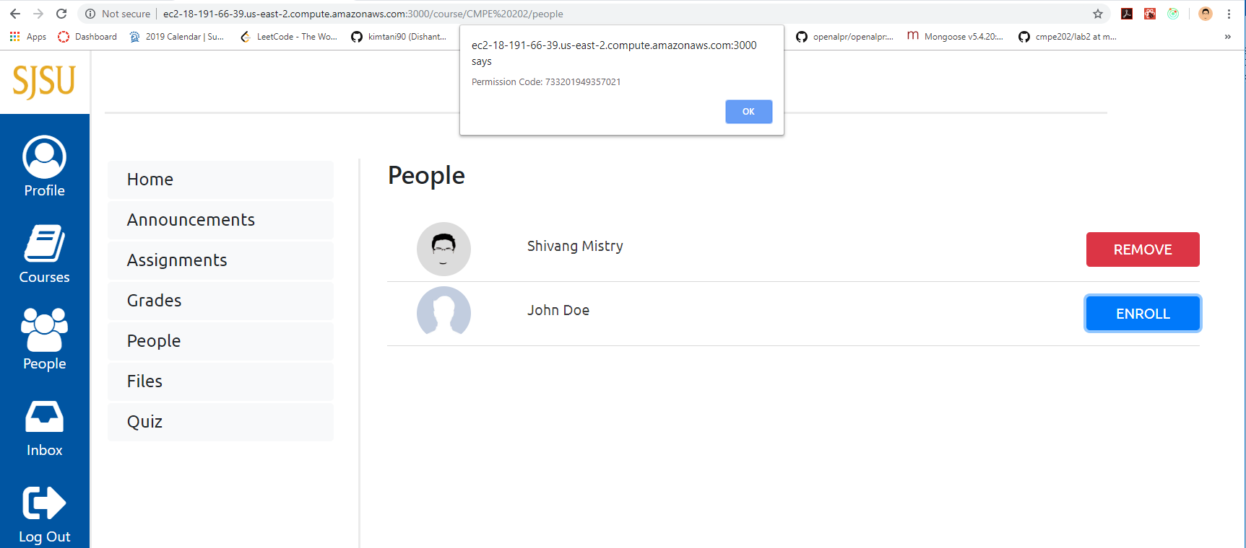





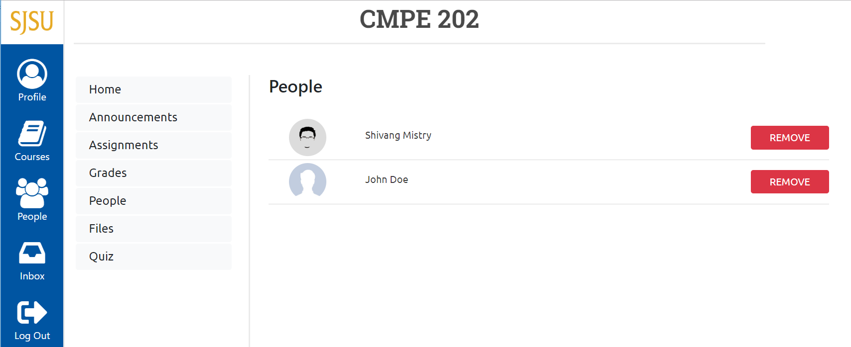

People view for student



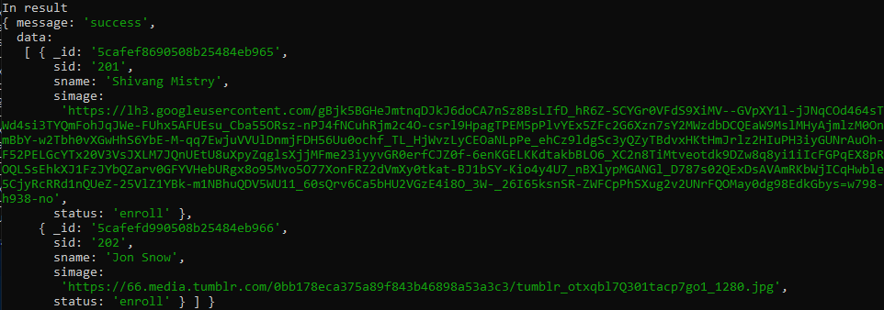

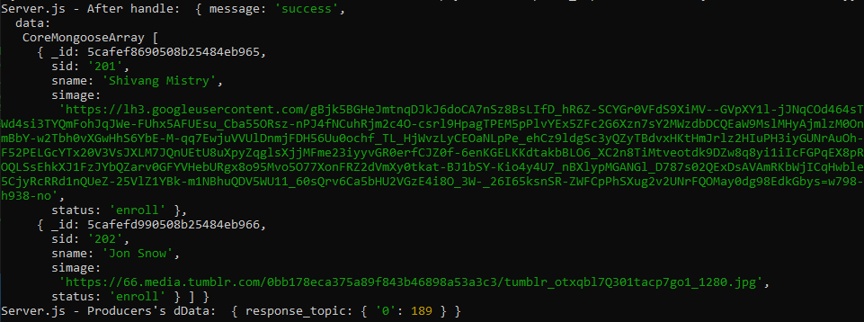

Faculty File view



Student File view







Faculty uploading file



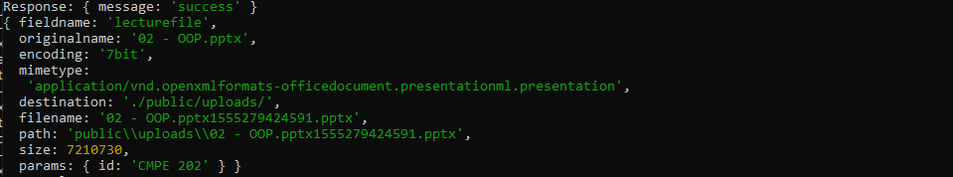

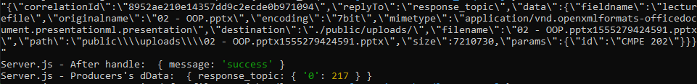



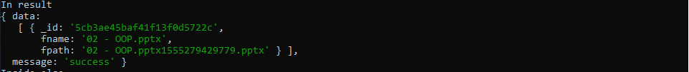

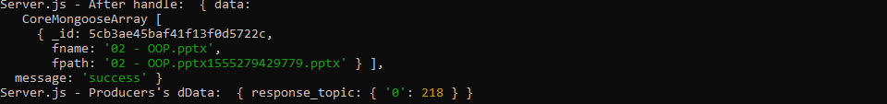

Files like assignments, lecture notes, submission can be accessed by simply clicking on the file name which will either download the file or open in new tab for supported files.

Faculty Quiz view

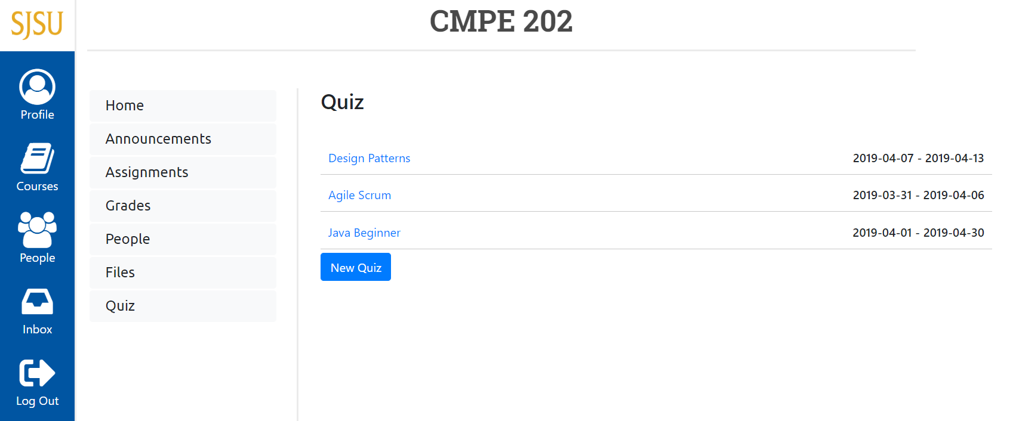

Student Quiz view

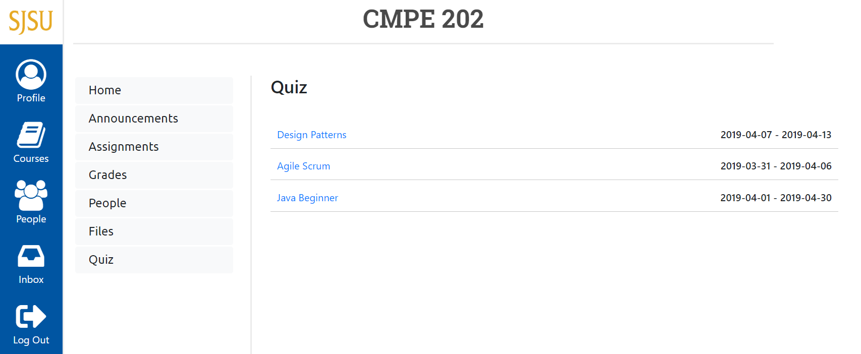

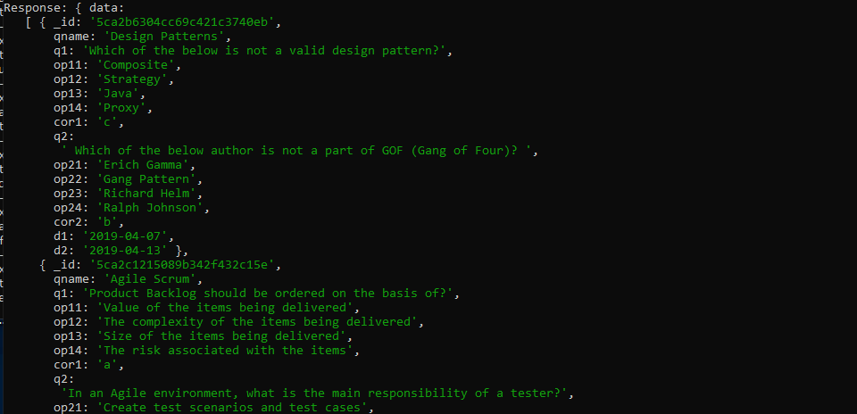

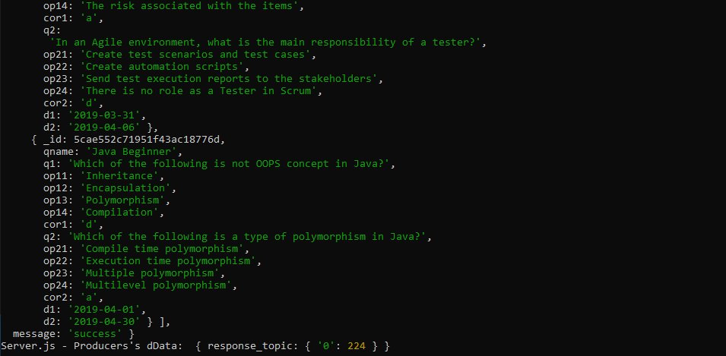

Faculty can only view the quiz created by them

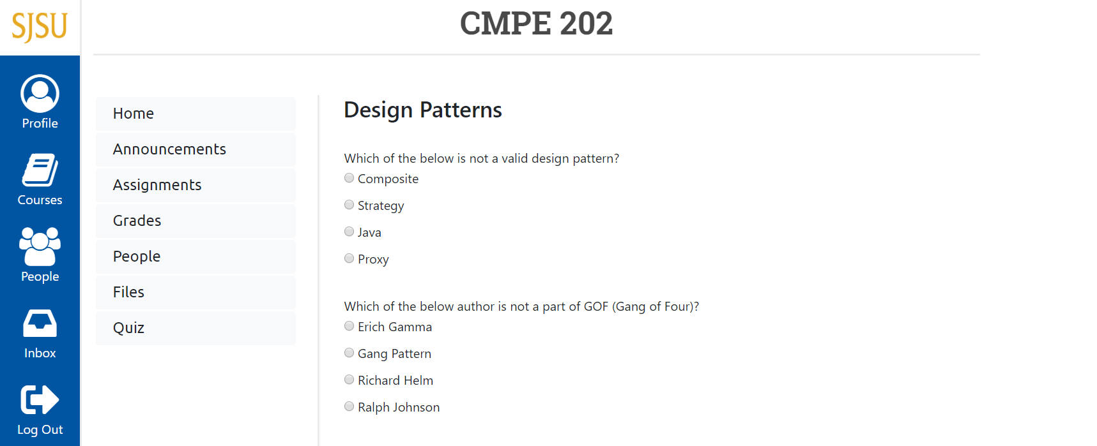

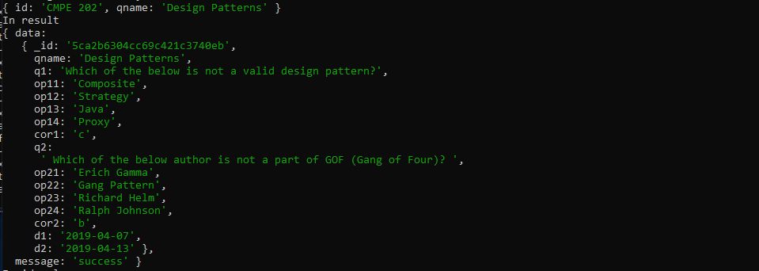

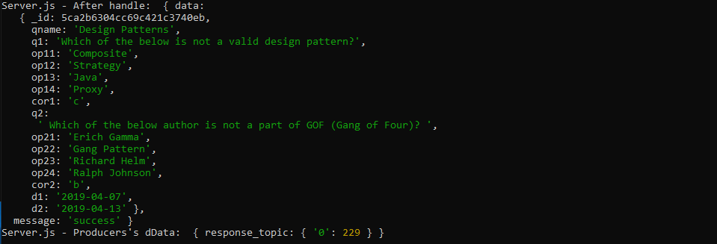

Student can submit quiz and get the grades for the same. Quiz will only be accessible to students during the dates mentioned. Students can only submit a quiz once.

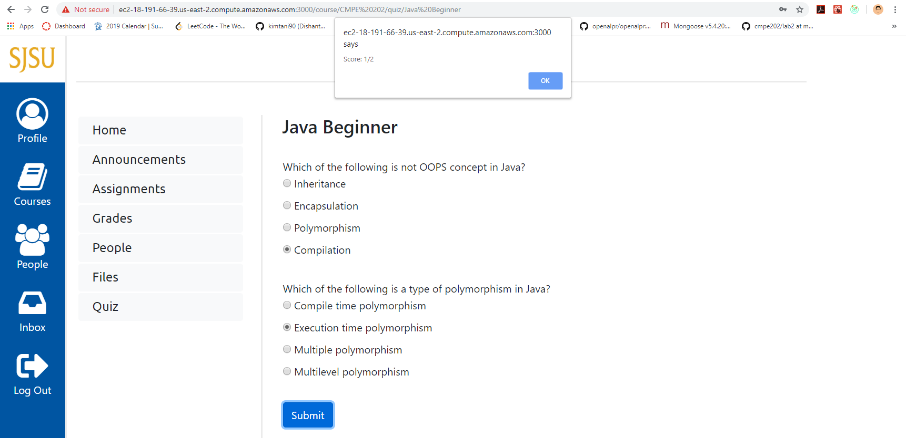



















**Performance**

**JMeter**

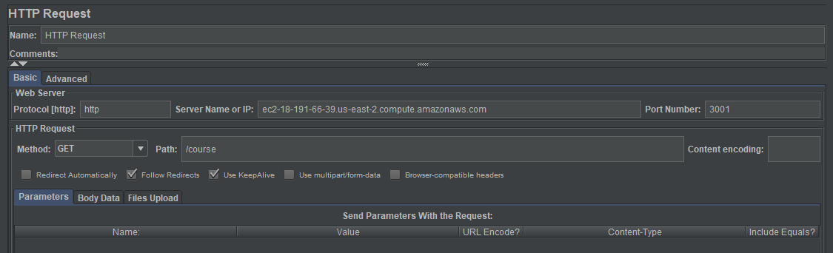

1. **Without connection pooling**

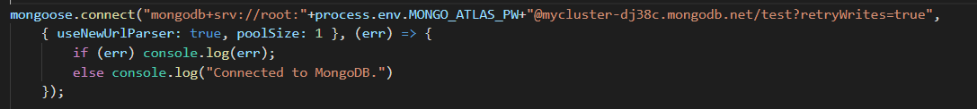

1. **100 concurrent users** – average: 1835 ms

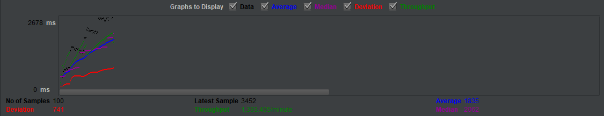

1. **200 concurrent users** – average: 2987 ms

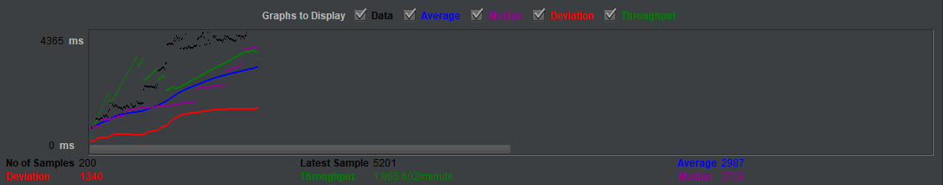

1. **300 concurrent users** – average: 4864 ms

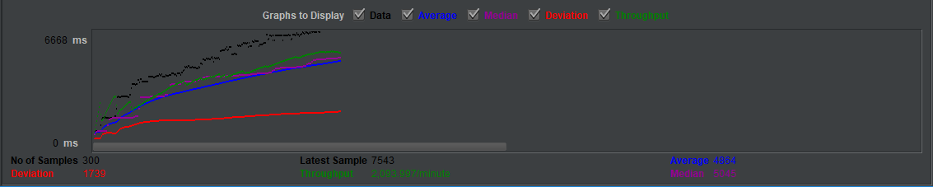

1. **400 concurrent users** – average: 5949 ms

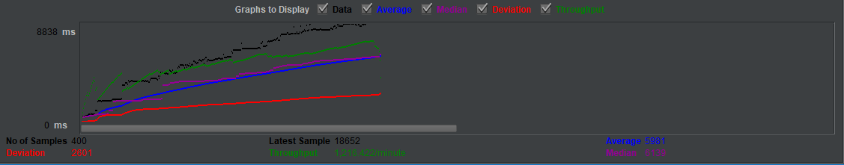

1. **500 concurrent users** – average: 8009 ms

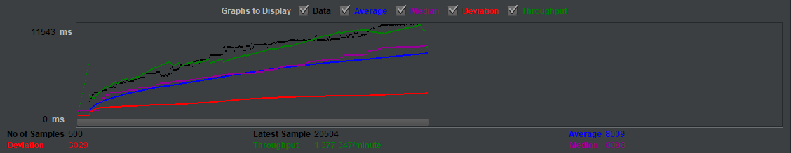

1. **Without connection pooling**

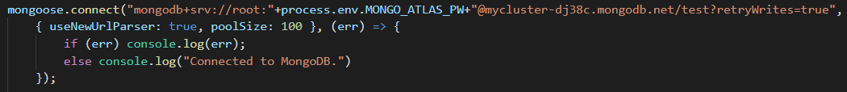

1. **100 concurrent users** – average: 795 ms

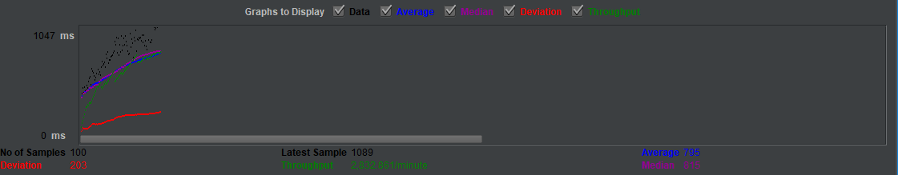

1. **200 concurrent users** – average: 1986 ms

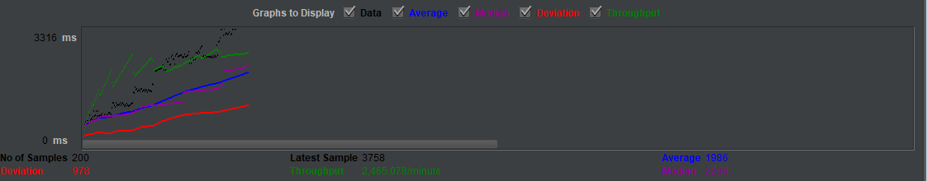

1. **300 concurrent users** – average: 3996 ms

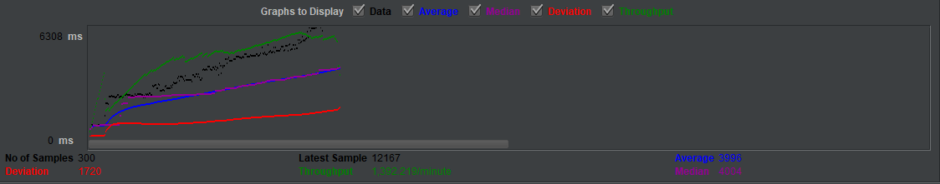

1. **400 concurrent users** – average: 4844 ms

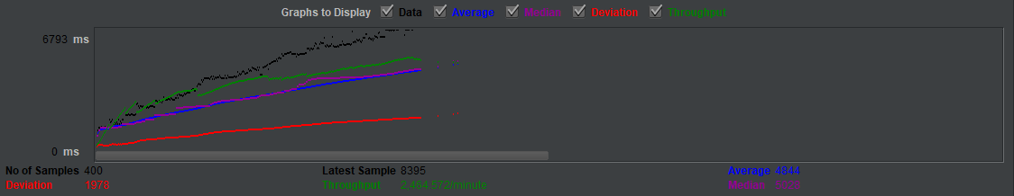

1. **500 concurrent users** – average: 6241 ms

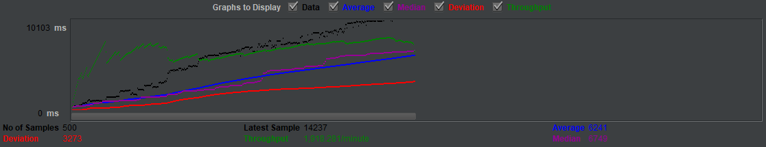

**Conclusion**

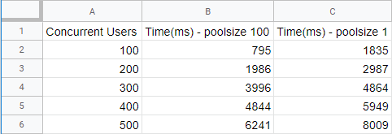

MongoDB performs connection pooling by implicitly with default pool size 5. In case 1, the pool size is set to 100 while in case 2, it is set to be1 to work without connection pooling. Looking at the result, clearly the average response time is directly proportional to the number of concurrent users and it also depends on pool size. When the number of users is approximately same as pool size, the average is lower; it increases rapidly once users crosses the pool size. On other hand, the time taken without connection pooling is always less compared to with pooling. This is because the pool size is set to one, server can only serve one user at a time, other requests will have to wait. Hence even if the operation takes less time, the overall average is more because of this bottleneck.

**Mocha Test**



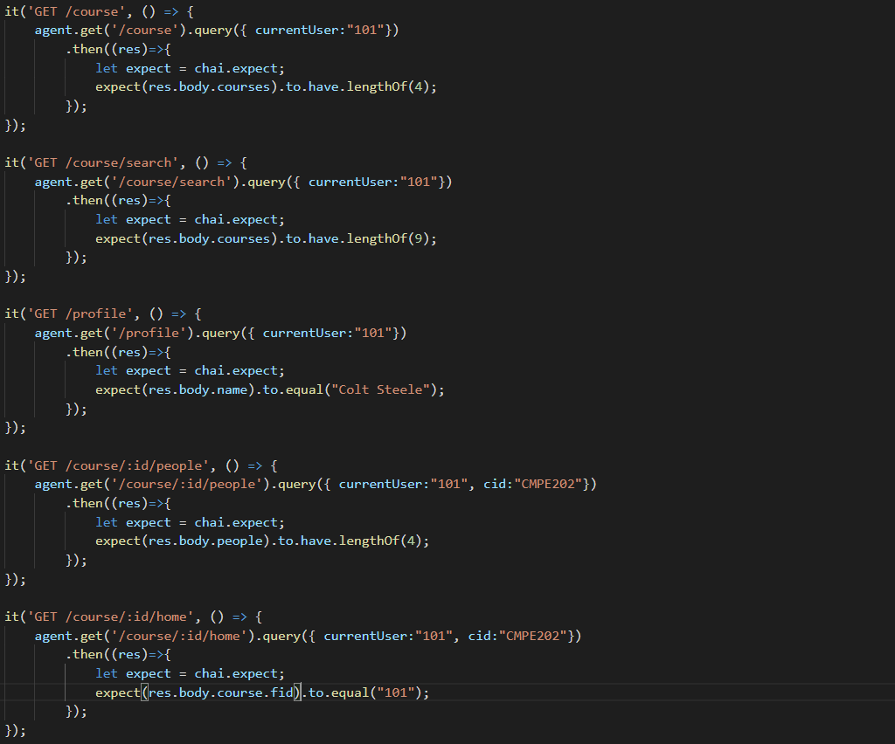

**Jest-Enzyme**

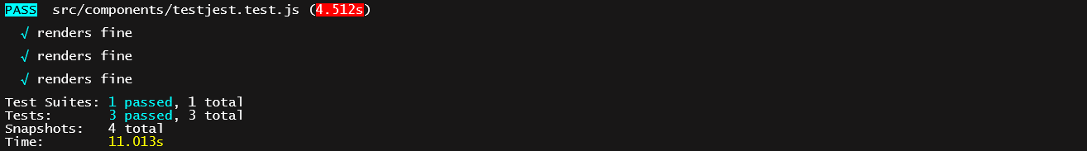

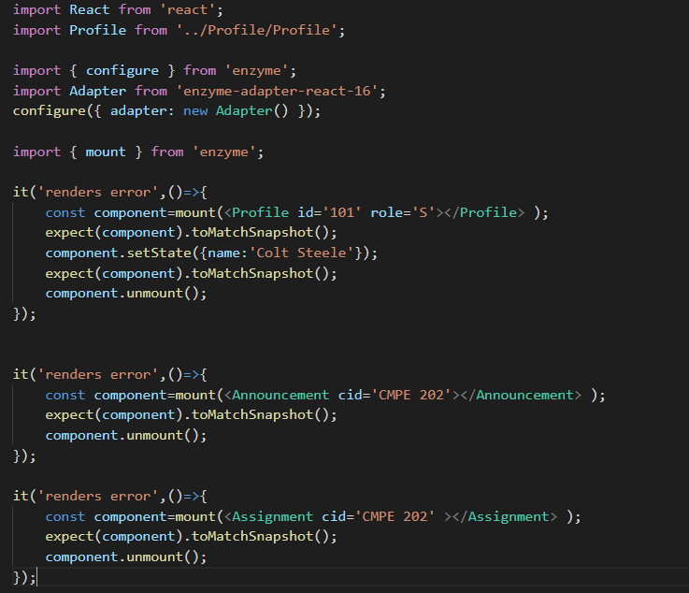

**Answers**

1. The following table was obtained for running tests

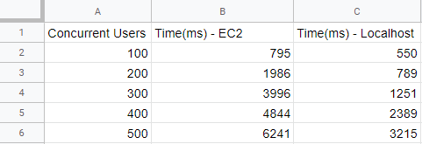

The above result table was obtained by comparing performance of Kafka, MongoDB deployed to cloud vs local machine on different set of concurrent users with same pool size 100. It is evident that the application gives more average response time when deployed on cloud compared to local instance. The change is also drastic. The average increases linearly with number of concurrent users. This result can be interpreted in the following ways: -

The local instance has all the resources it needs locally and hence the fetch is faster compared to the fetch on cloud.

Response may be slow due to network latency involved in application deployed to cloud. There is no such latency for local instance.

Available RAM is lower (1 GB) for the EC2 instance used in this deployment. Hence less data is cached on the EC2 instance compared to that on local machine which can have large RAM and caching.

MongoDB is sensitive to data used by RAM. Data fetch from RAM on local machine will mostly be faster.

HDD allows virtual memory whenever required to overcome high traffic. This is not possible due to its limitation.

Since Kafka is better for high traffic and the required resources are not available on EC2 instance, the average is lower.

This result can also depend on hardware configuration of EC2 and local machine.

2) MySQL is a type of Relational Database which stores data in form of row and column. They are used in application that heavily involves database transactions and referential integrity. It requires defining a structure ahead of implementing and defining primary and foreign keys. They are vertically scalable and sharding is possible on MySQL servers. They also support replication across multiple nodes.

On the other hand, MongoDB is a type of Non-relational database that represents data as collection of JSON format. The schema is flexible, and it offers greater efficiency and reliability. It is horizontally scalable. It doesn’t require a database administrator. It is faster for simpler queries. Unlike relational database, it allows modifying existing schema without affecting other documents.

If we are using MySQL, then normalizing data requires to perform join wherever necessary to extract data. This is a heavy-weight operation and it takes time unless data is cached. In this case, data retrieval from MongoDB is relatively fast. The write operation time will almost be same depending on the schema. On the other hand, using referential integrity, deleting a record is simpler in MySQL because of property like on delete cascade, null, etc. Since MongoDB has redundant data, it must be taken care of otherwise data will persist.

Considering these factors, I will choose to implement a combination of MySQL and MongoDB in the following manner: Only the user table can be made in MySQL with SJSU ID as primary key, Course and message table can be implemented using MongoDB. User table will be read/write/updated and never deleted. Handling many users can be achieved by vertical scalability. Message schema is only read/written. Using the message schema as described in the system design, there is no redundant document and data fetch is faster. Course schema will be the same as mentioned in the system design. Referential integrity is maintained as all the required foreign key values are available for that instance requiring the data. All courses will be identified with respect to their course id (_id). Remaining course attributes are either pushed or pulled as part of array which is light-weight compared to insert/delete operation in relational database. Operation like on delete cascade is handled through pulling many values from an array.

**Github Commits**

